Financial Management
INTRODUCTION
Enterprise group is the senior product of development of market economy, with the economic strength and good market adaptability, it gets a rapid development in the market competition. At the same time, along with the rapid development of information technology, the external environment of group financial management has greatly changed. There are many problems in the traditional financial management mode which are difficult to solve, no longer meeting the demand for group company management, and being not suitable for the trend of globalization of Group Company. Under the condition of the enterprise group scale unceasingly expanding, member companies geographically dispersion and business diversification, how can we high efficiently integrate the enterprise’s financial management information, support the business users at all levels of decision-making and monitor and regulate financial activities of member companies effectively through the financial management information has become the important problem in the current development of enterprise group. Now, both domestic and abroad scholars have being researching extensively and deeply on ERP and the application of ERP in corporation, and obtaining lots of achievement, which is of significance to research the group company financial management under ERP environment. Through the research of implementation of ERP, Stephen. Harwood pointed out that ERP is a comprehensive information system, this system severs various zones of business, ranging from processing business, and storing data to providing information. The system also has planning and control function, the efficiency of it is determined by whether the implementation is successful or not thought the life cycle. From the perspective of management and decision-making, David L Olson probed the problem which may exists in the application of ERP system. He pointed out that ERP system should server the strategy and adapt to actual situation of enterprises. Zhen Fuming raised an issue that the implementation of ERP is related to the maturity scale of the enterprise, the process of implementation of ERP is the dynamic process of enterprise’s ability degree. Based on value chain theory and information technology. With related research on financial management informatization, Zhang Raijin put forward the innovation pattern of financial informatization management based on Value chain theory and information technology, that is in connection with the best way to implement the group company’s financial management. Yang Xuedong pointed out that the financial situation of group company can be supervisory through ERP, ERP also can promote the mode of financial management from accounting to management, to form a real-time and dynamic management mode, it contributes to improving the level of enterprise’s risk forewarning and the level of performance evaluation. Xiao Hong pointed out that ERP can connect the production and financial management in enterprise, enable the information of various sub-systems shared widely, overcome the deficiencies of traditional financial management, reflect the business condition timely, play a role of pre-warning with financial situation.
1.1 Objective of the project:
Financial management is an important link in the financial management of colleges and universities. On the basis of the analysis of the defects in the traditional financial management methods, the financial management theory and the early warning theory of the colleges and universities are combined in this paper. The data mining algorithm is applied to establish the financial management information system model of the colleges and universities. Firstly, A universities in both Shanghai City and Shenzhen City in the recent two years are taken as the research subjects. The colleges and universities that are included in the special treatment due to the abnormal financial situation are defined as the financial crisis sign for the colleges and universities. In addition, the financial data in the annual report of the colleges and universities are adopted as the input feature vector, and then the data mining algorithm is combined with the data mining to establish a kind of financial management information system model of the colleges and universities through the empirical methods.
2. LITERATURE SURVEY:
“ERP: the implementation cycle,”
Stephen, Harwood, 2003
This paper aims to study the shortcomings of the business process of credit card department of a multinational bank and to improve the existing business process efficiency and effectiveness through redesigning the process that eliminates bottlenecks and improves service quality. Design/methodology/approach – The research investigates real-life business process using case study methodology. It collects primary data through interviews of individuals, focus groups and secondary data from the investigation of company documents. It then uses SWOT analysis, Fishbone Diagram, Process Flow Diagram and a number of other tools to analyse and to redesign the existing process. Findings – The research identifies that the business process of the credit card department of a multinational bank is unnecessarily lengthy and requires eight to nine days to complete from application processing to final account creation and to issue the card. It then designs a to-be business process for the same business function. The proposed process reduces half of the time of the existing process. Practical implications – The proposed business process reduces the cycle time effectively and uses the organisational resources efficiently to achieve better customer satisfaction. It also helps in growing card market share in this highly competitive and profitable segment of consumer products. Originality/value – This paper illustrates a unique way of investigating an existing business process and designing a new business process that is very efficient and effective. The design process is quite generic which can be applied to other organisations, especially in the banking sector.
"A Study of Risk Management in ERP Implementation, "
Zhen Fuming, 2008
Enterprise resource planning (ERP) projects are risky. But if they are implemented appropriately, they can provide competitive advantage to organisations. Therefore, ERP implementation has become one of the most critical aspects of today's information management research. The main purpose of this article is to describe a new ERP risk assessment framework (RAF) that can be used to increase the success of ERP implementation. In this article, through a case study based in a leading UK-based energy service provider, we demonstrate the new RAF, which has been shown to help identify and mitigate risks in ERP implementation. In contrast to other research, this RAF identifies risks hierarchically in external engagement, programme management, work stream and work package levels across technical, schedule, operational, business and organisational categories. This not only helped to develop responses to mitigate risks but also facilitates on-going risk control.
"Financial and Accounting management Innovation in IT Environment,"
Zhang Raijin, 2008
The value chain theory is a powerful tool for the enterprise financial BPR. By eliminating non-value-added chain, the enterprise can realize the maximum value of financial processes, in order to achieve the goal of maximizing the value of enterprise. Using the value chain theory and the modern information technology, this paper analyses the existing financial processes, sets up the financial BPR frame model. Among them, the design idea of vouchers of converting module is elaborated and evaluation indicators are proposed.
"The Impact and challenges of ERP to Enterprise Group's Financial Management,"
Yang Xuedong, 2008
Over the last decade Enterprise Resource Planning (ERP) have been adopted by many companies as it contributes to the development and profitability of the organizations by business solutions. Once configured it allows information to enter at a single point in the process, and also updates a single, shared data base for all functions that directly or indirectly depend on this information. These are a set of applications combining key functions like finance, production. Sales, logistics, statutory compliance, human resources etc., in an integrated fashion. In a manner these combine Enterprise Resource Planning system with extended enterprise needs likes software solutions to the employees, customers and vendors. ERP not only helps to establish world class best business solutions and bring transparency in the business. This paper presents the definition, ERP Systems concept and need, the historical evolution of the ERP Systems, why is ERP Systems needed, why firms invest in ERP Systems, business performance development with ERP Systems, the scope of the ERP Systems, ERP model, ERP architecture, ERP implementation approaches have been discussed.
"Analysis of the ERP system's Financial management characteristic,"
Xiao Hong, 2009
Enterprise resource planning (ERP) system is one of the most widely accepted choices to obtain competitive advantage for manufacturing companies. However, the successful implementation rate is low and many firms did not achieve intended goals in China. This study develops an ERP implementation success framework by adapting the Ives et al. information systems (ISs) research model and Delone and McLean's IS success model to identify both critical success factors and success measures. Qualitative case study research methodology is used to collect data and Atlas/it program is used to facilitate data analysis. Discussion is made finally and suggested ERP systems implementation methodology is given at the end.
"Research on the ERP-based Integrated Financial Management Mode of Enterprise Groups,"
Yu Meilin, 2008
This article analyses the characteristics of financial management mode in the traditional environment, discusses how to construct the ERP-based integrated financial management mode, proposes concrete design contents of integrated financial management mode in enterprise groups including the establishment of a comprehensive budget management system, construction of centralized fund management system, establishment of risk management system and improvement of internal financial control.
"The Implementation Case of Wuhan Iron and Steel Group's Financial Management System,"
Long Zhi, 2007
This case explores the mechanism of equity governance model when multinational companies enter overseas markets. It does this by analysing seven investment projects carried out by WISCO in five countries. This case introduces these projects and sorts through the equity scenarios of each, clarifying the relationship between equity setting and national institutional support, and establishing the parameters of the Waging (Waging is short for Wuhan Iron and Steel Corporation) model. Lastly, the scientific nature of the Waging model is analysed from the perspective of institutional theory.
"The Application of ERP system in Enterprise Management,"
Yu Hui, 2009
Cost management is an important part of strategic management of manufacturing enterprises and plays an irreplaceable role in the development of manufacturing enterprises. The reality is that many manufacturing companies have problems with cost management. For example, the cost accounting cycle is long, and the cost allocation method is not scientific, and the cost management method is obsolete. The application of ERP system can solve the cost management problem of manufacturing enterprises. Therefore, this paper puts forward some suggestions from the aspects of optimizing the selection of ERP system, and strengthening the application of ERP system, and strengthening personnel training , and doing well the maintenance of ERP system.
"Analysis of Shandong Dong-e E-Jiao Group's ERP System Applications,"
Shen Kwang, 2010
With the formation of the pattern of economic globalization, China's logistics industry has developed rapidly in recent years, logistics informatization has been developed to a large extent, the awareness of enterprise logistics informatization has generally improved, and the process of using ERP systems in the logistics industry is also accelerating. Relying on the advantages of advanced information technology, ERP system is gradually applied in the enterprise management system, especially in the logistics management plays a vital role. In this context, based on the application of ERP system, it analyses its role and problems in enterprise logistics management, and proposes effective application strategies for analysis and discussion.
3. SYSTEM ANALYSIS
3.1 Existing System
In existing system, uses traditional methods to manage and forecast personal expenses. Users typically rely on basic budgeting tools that lack predictive capabilities. These tools provide historical data and categorize expenses but don't offer advanced forecasting or recommendations for future budgeting. The forecasting models used are often based on simplistic calculations and do not adapt to the changing financial behaviour of the user.
Disadvantages:
- Limited Forecasting Capabilities
- No Recommendations
- Inflexible
- Manual Input
- Basic Categorization
3.2 Proposed System
The proposed system employs advanced AI-based algorithms to forecast future expenses based on historical data. It uses multiple algorithms like Random Forest, Decision Tree, and CNN2D to predict upcoming expenses accurately. The system not only predicts future costs but also recommends new expenses to users, helping them plan their budgets effectively. The performance of each algorithm is evaluated using metrics such as MSE, RMSE, and R2Score to ensure accurate and reliable forecasting. The system adapts to the user's financial behaviour, providing a more personalized and accurate budget management tool.
Advantages:
- Accurate Forecasting
- Personalized Recommendations
- Adaptability
- Advanced Metrics Evaluation
- Data-Driven Insights
3.3. PROCESS MODEL USED WITH JUSTIFICATION
SDLC (Umbrella Model):
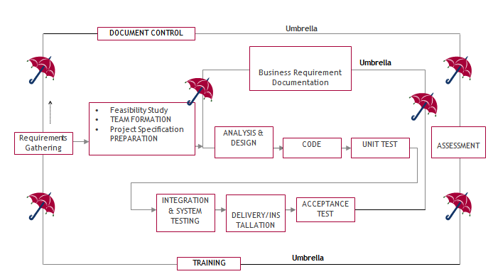

SDLC is nothing but Software Development Life Cycle. It is a standard which is used by software industry to develop good software.
Stages in SDLC:
- Requirement Gathering
- Analysis
- Designing
- Coding
- Testing
- Maintenance
Requirements Gathering stage:
The requirements gathering process takes as its input the goals identified in the high-level requirements section of the project plan. Each goal will be refined into a set of one or more requirements. These requirements define the major functions of the intended application, define operational data areas and reference data areas, and define the initial data entities. Major functions include critical processes to be managed, as well as mission critical inputs, outputs and reports. A user class hierarchy is developed and associated with these major functions, data areas, and data entities. Each of these definitions is termed a Requirement. Requirements are identified by unique requirement identifiers and, at minimum, contain a requirement title and textual description.
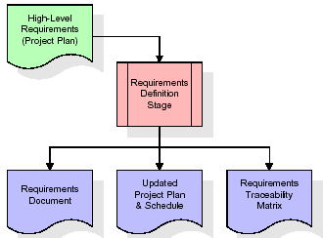
These requirements are fully described in the primary deliverables for this stage: the Requirements Document and the Requirements Traceability Matrix (RTM). The requirements document contains complete descriptions of each requirement, including diagrams and references to external documents as necessary. Note that detailed listings of database tables and fields are not included in the requirements document.
The title of each requirement is also placed into the first version of the RTM, along with the title of each goal from the project plan. The purpose of the RTM is to show that the product components developed during each stage of the software development lifecycle are formally connected to the components developed in prior stages.
In the requirements stage, the RTM consists of a list of high-level requirements, or goals, by title, with a listing of associated requirements for each goal, listed by requirement title. In this hierarchical listing, the RTM shows that each requirement developed during this stage is formally linked to a specific product goal. In this format, each requirement can be traced to a specific product goal, hence the term requirements traceability.
The outputs of the requirements definition stage include the requirements document, the RTM, and an updated project plan.
- Feasibility study is all about identification of problems in a project.
- No. of staff required to handle a project is represented as Team Formation, in this case only modules are individual tasks will be assigned to employees who are working for that project.
- Project Specifications are all about representing of various possible inputs submitting to the server and corresponding outputs along with reports maintained by administrator.
Analysis Stage:
The planning stage establishes a bird's eye view of the intended software product, and uses this to establish the basic project structure, evaluate feasibility and risks associated with the project, and describe appropriate management and technical approaches.
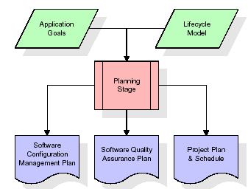
The most critical section of the project plan is a listing of high-level product requirements, also referred to as goals. All of the software product requirements to be developed during the requirements definition stage flow from one or more of these goals. The minimum information for each goal consists of a title and textual description, although additional information and references to external documents may be included. The outputs of the project planning stage are the configuration management plan, the quality assurance plan, and the project plan and schedule, with a detailed listing of scheduled activities for the upcoming Requirements stage, and high level estimates of effort for the out stages.
Designing Stage:
The design stage takes as its initial input the requirements identified in the approved requirements document. For each requirement, a set of one or more design elements will be produced as a result of interviews, workshops, and/or prototype efforts. Design elements describe the desired software features in detail, and generally include functional hierarchy diagrams, screen layout diagrams, tables of business rules, business process diagrams, pseudo code, and a complete entity-relationship diagram with a full data dictionary. These design elements are intended to describe the software in sufficient detail that skilled programmers may develop the software with minimal additional input.
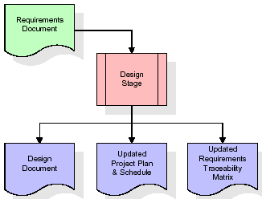
When the design document is finalized and accepted, the RTM is updated to show that each design element is formally associated with a specific requirement. The outputs of the design stage are the design document, an updated RTM, and an updated project plan.
Development (Coding) Stage:
The development stage takes as its primary input the design elements described in the approved design document. For each design element, a set of one or more software artifacts will be produced. Software artifacts include but are not limited to menus, dialogs, and data management forms, data reporting formats, and specialized procedures and functions. Appropriate test cases will be developed for each set of functionally related software artifacts, and an online help system will be developed to guide users in their interactions with the software.
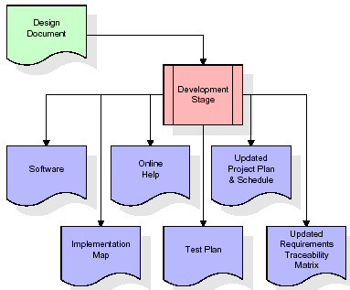

The RTM will be updated to show that each developed artifact is linked to a specific design element, and that each developed artifact has one or more corresponding test case items. At this point, the RTM is in its final configuration. The outputs of the development stage include a fully functional set of software that satisfies the requirements and design elements previously documented, an online help system that describes the operation of the software, an implementation map that identifies the primary code entry points for all major system functions, a test plan that describes the test cases to be used to validate the correctness and completeness of the software, an updated RTM, and an updated project plan.
Integration & Test Stage:
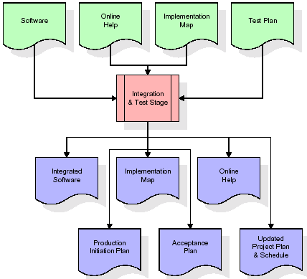
During the integration and test stage, the software artifacts, online help, and test data are migrated from the development environment to a separate test environment. At this point, all test cases are run to verify the correctness and completeness of the software. Successful execution of the test suite confirms a robust and complete migration capability. During this stage, reference data is finalized for production use and production users are identified and linked to their appropriate roles. The final reference data (or links to reference data source files) and production user list are compiled into the Production Initiation Plan.

The outputs of the integration and test stage include an integrated set of software, an online help system, an implementation map, a production initiation plan that describes reference data and production users, an acceptance plan which contains the final suite of test cases, and an updated project plan.
- Installation & Acceptance Test:
During the installation and acceptance stage, the software artifacts, online help, and initial production data are loaded onto the production server. At this point, all test cases are run to verify the correctness and completeness of the software. Successful execution of the test suite is a prerequisite to acceptance of the software by the customer.
After customer personnel have verified that the initial production data load is correct and the test suite has been executed with satisfactory results, the customer formally accepts the delivery of the software.
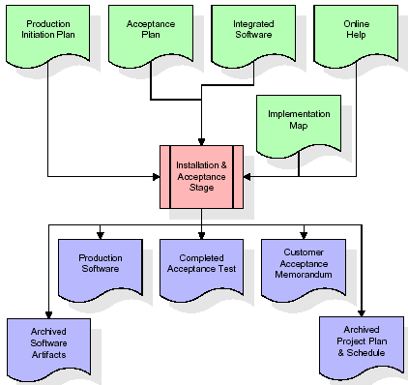
The primary outputs of the installation and acceptance stage include a production application, a completed acceptance test suite, and a memorandum of customer acceptance of the software. Finally, the PDR enters the last of the actual labor data into the project schedule and locks the project as a permanent project record. At this point the PDR "locks" the project by archiving all software items, the implementation map, the source code, and the documentation for future reference.
Maintenance:
Outer rectangle represents maintenance of a project, Maintenance team will start with requirement study, understanding of documentation later employees will be assigned work and they will undergo training on that particular assigned category. For this life cycle there is no end, it will be continued so on like an umbrella (no ending point to umbrella sticks).
3.4. Software Requirement Specification
3.4.1. Overall Description
A Software Requirements Specification (SRS) – a requirements specification for a software system is a complete description of the behaviour of a system to be developed. It includes a set of use cases that describe all the interactions the users will have with the software. In addition to use cases, the SRS also contains non-functional requirements. Non-functional requirements are requirements which impose constraints on the design or implementation (such as performance engineering requirements, quality standards, or design constraints).
System requirements specification: A structured collection of information that embodies the requirements of a system. A business analyst, sometimes titled system analyst, is responsible for analysing the business needs of their clients and stakeholders to help identify business problems and propose solutions. Within the systems development lifecycle domain, the BA typically performs a liaison function between the business side of an enterprise and the information technology department or external service providers. Projects are subject to three sorts of requirements:
- Business requirements describe in business terms what must be delivered or accomplished to provide value.
- Product requirements describe properties of a system or product (which could be one of several ways to accomplish a set of business requirements.)
- Process requirements describe activities performed by the developing organization. For instance, process requirements could specify .Preliminary investigation examine project feasibility, the likelihood the system will be useful to the organization. The main objective of the feasibility study is to test the Technical, Operational and Economical feasibility for adding new modules and debugging old running system. All system is feasible if they are unlimited resources and infinite time. There are aspects in the feasibility study portion of the preliminary investigation:
- ECONOMIC FEASIBILITY
A system can be developed technically and that will be used if installed must still be a good investment for the organization. In the economic feasibility, the development cost in creating the system is evaluated against the ultimate benefit derived from the new systems. Financial benefits must equal or exceed the costs. The system is economically feasible. It does not require any addition hardware or software. Since the interface for this system is developed using the existing resources and technologies available at NIC, there is nominal expenditure and economic feasibility for certain.
- Operational Feasibility
Proposed projects are beneficial only if they can be turned out into information system. That will meet the organization’s operating requirements. Operational feasibility aspects of the project are to be taken as an important part of the project implementation. This system is targeted to be in accordance with the above-mentioned issues. Beforehand, the management issues and user requirements have been taken into consideration. So there is no question of resistance from the users that can undermine the possible application benefits. The well-planned design would ensure the optimal utilization of the computer resources and would help in the improvement of performance status.
- TECHNICAL FEASIBILITY
Earlier no system existed to cater to the needs of ‘Secure Infrastructure Implementation System’. The current system developed is technically feasible. It is a web-based user interface for audit workflow at NIC-CSD. Thus, it provides an easy access to. the users. The database’s purpose is to create, establish and maintain a workflow among various entities in order to facilitate all concerned users in their various capacities or roles. Permission to the users would be granted based on the roles specified. Therefore, it provides the technical guarantee of accuracy, reliability and security.
3.4.2. External Interface Requirements
User Interface
The user interface of this system is a user friendly python Graphical User Interface.
Hardware Interfaces
The interaction between the user and the console is achieved through python capabilities.
Software Interfaces
The required software is python.
SYSTEM REQUIREMENT:
HARDWARE REQUIREMENTS:

Processor - Intel i3(min)
- Speed - 1.1 GHz
- RAM - 4GB(min)
- Hard Disk - 500 GB
SOFTWARE REQUIREMENTS:
- Operating System - Windows10(min)
- Programming Language - Python with Jupiter notebook
4. SYSTEM DESIGN
UML Diagram:
The Unified Modelling Language allows the software engineer to express an analysis model using the modelling notation that is governed by a set of syntactic semantic and pragmatic rules.
A UML system is represented using five different views that describe the system from distinctly different perspective. Each view is defined by a set of diagram, which is as follows.
  - User Model View
    - This view represents the system from the users perspective.
    - The analysis representation describes a usage scenario from the end-users perspective.
  - Structural Model view
    - In this model the data and functionality are arrived from inside the system.
    - This model view models the static structures.
- Behavioural Model View
It represents the dynamic of behavioural as parts of the system, depicting the interactions of collection between various structural elements described in the user model and structural model view.
- Implementation Model View
In this the structural and behavioural as parts of the system are represented as they are to be built.
- Environmental Model View
In this the structural and behavioural aspects of the environment in which the system is to be implemented are represented.
Class Diagram:
The class diagram is the main building block of object oriented modeling. It is used both for general conceptual modeling of the systematic of the application, and for detailed modeling translating the models into programming code. Class diagrams can also be used for data modeling. The classes in a class diagram represent both the main objects, interactions in the application and the classes to be programmed. In the diagram, classes are represented with boxes which contain three parts:
- The upper part holds the name of the class
- The middle part contains the attributes of the class
- The bottom part gives the methods or operations the class can take or undertake.

Use case Diagram:
A use case diagram at its simplest is a representation of a user's interaction with the system and depicting the specifications of a use case. A use case diagram can portray the different types of users of a system and the various ways that they interact with the system. This type of diagram is typically used in conjunction with the textual use case and will often be accompanied by other types of diagrams as well.

Sequence diagram:
A sequence diagram is a kind of interaction diagram that shows how processes operate with one another and in what order. It is a construct of a Message Sequence Chart. A sequence diagram shows object interactions arranged in time sequence. It depicts the objects and classes involved in the scenario and the sequence of messages exchanged between the objects needed to carry out the functionality of the scenario. Sequence diagrams are typically associated with use case realizations in the Logical View of the system under development. Sequence diagrams are sometimes called event diagrams, event scenarios, and timing diagrams.

Collaboration diagram:
A collaboration diagram describes interactions among objects in terms of sequenced messages. Collaboration diagrams represent a combination of information taken from class, sequence, and use case diagrams describing both the static structure and dynamic behaviour of a system.

Component Diagram:
In the Unified Modelling Language, a component diagram depicts how components are wired together to form larger components and or software systems. They are used to illustrate the structure of arbitrarily complex systems.
Components are wired together by using an assembly connector to connect the required interface of one component with the provided interface of another component. This illustrates the service consumer - service provider relationship between the two components.

Deployment Diagram:
A deployment diagram in the Unified Modeling Language models the physical deployment of artifacts on nodes. To describe a web site, for example, a deployment diagram would show what hardware components ("nodes") exist (e.g., a web server, an application server, and a database server), what software components ("artifacts") run on each node (e.g., web application, database), and how the different pieces are connected (e.g. JDBC, REST, RMI).
The nodes appear as boxes, and the artifacts allocated to each node appear as rectangles within the boxes. Nodes may have sub nodes, which appear as nested boxes. A single node in a deployment diagram may conceptually represent multiple physical nodes, such as a cluster of database servers.
Activity Diagram:
Activity diagram is another important diagram in UML to describe dynamic aspects of the system. It is basically a flow chart to represent the flow form one activity to another
activity. The activity can be described as an operation of the system. So the control flow is drawn from one operation to another. This flow can be sequential, branched or concurrent

Run CNN Algorithm
Prediction
User
Upload Dataset
Preprocess Dataset

Run Random Forest

Run Decision Tree
System

Data Flow Diagram:
Data flow diagrams illustrate how data is processed by a system in terms of inputs and outputs. Data flow diagrams can be used to provide a clear representation of any business function. The technique starts with an overall picture of the business and continues by analysing each of the functional areas of interest. This analysis can be carried out in precisely the level of detail required. The technique exploits a method called top-down expansion to conduct the analysis in a targeted way.
As the name suggests, Data Flow Diagram (DFD) is an illustration that explicates the passage of information in a process. A DFD can be easily drawn using simple symbols. Additionally, complicated processes can be easily automated by creating DFDs using easy-to-use, free downloadable diagramming tools. A DFD is a model for constructing and analysing information processes. DFD illustrates the flow of information in a process depending upon the inputs and outputs. A DFD can also be referred to as a Process Model. A DFD demonstrates business or technical process with the support of the outside data saved, plus the data flowing from the process to another and the end results.
User
System

1. Upload Dataset 2. Dataset upload successfully
3. Preprocess 4. Dataset Preprocessed
5. Run Random Forest 6. Run Random Forest Successfully
7. Run Decision Tree 8. Run Decision Tree Successfully
9. Run CNN Algorithm 10. Run CNN Algorithm Successfully
11. Prediction 12. Successfully Predicted

5. IMPLEMETATION
5.1 PYTHON
* One of the most popular languages is Python. Guido van Rossum released this language in 1991. Python is available on the Mac, Windows, and Raspberry Pi operating systems. The syntax of Python is simple and identical to that of English. When compared to Python, it was seen that the other language requires a few extra lines.
*It is an interpreter-based language because code may be run line by line after it has been written. This implies that rapid prototyping is possible across all platforms. Python is a big language with a free, binary-distributed interpreter standard library.
* It is inferior to maintenance that is conducted and is straightforward to learn. It is an object-oriented, interpreted programming language. It supports several different programming paradigms in addition to object-oriented programming, including functional and procedural programming.
* It supports several different programming paradigms in addition to object-oriented programming, including practical and procedural programming. Python is mighty while maintaining a relatively straightforward syntax. Classes, highly dynamic data types, modules, and exceptions are covered. Python can also be utilised by programmes that require programmable interfaces as an external language.
Here are some key features and characteristics of Python:
- Readability: Python emphasizes code readability with its clean and intuitive syntax. It uses indentation and whitespace to structure code blocks, making it easy to understand and maintain.
- Easy to Learn: Python's simplicity and readability make it an excellent choice for beginners. Its straightforward syntax and extensive documentation make it accessible for newcomers to programming.
- Interpreted Language: Python is an interpreted language, meaning that it doesn't need to be compiled before running. The Python interpreter reads and executes the code directly, making the development process faster and more interactive.
- Cross-platform Compatibility: Python is available for major operating systems like Windows, macOS, and Linux. This cross-platform compatibility allows developers to write code once and run it on different platforms without modifications.
- Large Standard Library: Python comes with a vast standard library that provides ready-to-use modules and functions for various tasks. It covers areas such as file I/O, networking, regular expressions, databases, and more, saving developers time and effort.
- Extensible and Modular: Python supports modular programming, enabling developers to organize code into reusable modules and packages. Additionally, Python allows integrating modules written in other languages, such as C or C++, providing flexibility and performance optimizations.
- Wide Range of Libraries and Frameworks: Python has a vibrant ecosystem with numerous third-party libraries and frameworks. These libraries, such as NumPy, pandas, TensorFlow, and Django, extend Python's capabilities for specific domains, making it a powerful tool for diverse applications.
- Object-Oriented: Python supports object-oriented programming (OOP) principles, allowing developers to create and work with classes and objects. OOP provides a structured approach to code organization, promoting code reuse and modularity.
- Dynamic Typing: Python is dynamically typed, meaning variable types are determined at runtime. Developers do not need to declare variable types explicitly, which enhances flexibility and simplifies code writing.
5.2 Installation
To install Python on your computer, follow these basic steps:
- Step 1: Visit the Python website Go to the official Python website at https://www.python.org/.
- Step 2: Select the operating system Choose the appropriate installer for your operating system. Python supports Windows, macOS, and various Linux distributions. Make sure to select the correct version that matches your operating system.
- Step 3: Check which version of Python is installed; if the 3.7.0 version is not there, uninstall it through the control panel and
- Step 4: Install Python 3.7.0 using Cmd.
- Step 5: Install the all libraries that required to run the project
- Step 6: Run
5.3 Python Features:
- Easy: Because Python is a more accessible and straightforward language, Python programming is easier to learn.
- Interpreted language: Python is an interpreted language, therefore it can be used to examine the code line by line and provide results.
- Open Source: Python is a free online programming language since it is open-source.
- Portable: Python is portable because the same code may be used on several computer standard
- libraries: Python offers a sizable library that we may utilize to create applications quickly.
- GUI: It stands for GUI (Graphical User Interface)
- Dynamical typed: Python is a dynamically typed language; therefore the type of the value will be determined at runtime.
5.4 Python GUI (Tkinter)
- Python provides a wide range of options for GUI development (Graphical User Interfaces).
- Tkinter, the most widely used GUI technique, is used for all of them.
- The Tk GUI toolkit offered by Python is used with the conventional Python interface.
- Tkinter is the easiest and quickest way to write Python GUI programs.
- Using Tkinter, creating a GUI is simple.
- A part of Python's built-in library is Tkinter. The GUI programs were created.
- Python and Tkinter together give a straightforward and quick way. The Tk GUI toolkit's object-oriented user interface is called Tkinter.

Making a GUI application is easy using Tkinter. Following are the steps:
1) Install the Tkinter module in place.
2) The GUI application Makes the primary window
3) Include one or more of the widgets mentioned above in the GUI application.
4) Set up the main event loop such that it reacts to each user-initiated event.
Although Tkinter is the only GUI framework included in the Python standard library, Python includes a GUI framework. The default library for Python is called Tkinter. Tk is a scripting language often used in designing, testing, and developing GUIs. Tk is a free, open-source widget toolkit that may be used to build GUI applications in a wide range of computer languages.
5.5 Python IDLE
- Python IDLE offers a full-fledged file editor, which gives you the ability to write and execute Python programs from within this program. The built-in file editor also includes several features, like code completion and automatic indentation, that will speed up your coding workflow.
- Guido Van Rossum named Python after the British comedy group Monty Python while the name IDLE was chosen to pay tribute to Eric Idle, who was one of the Monty Python's founding members. IDLE comes bundled with the default implementation of the Python language since the 01.5. 2b1 release
- IDLE is used to execute statements similar to Python Shell. IDLE is used to create, modify, and execute Python code. IDLE provides a fully-featured text editor to write Python scripts and provides features like syntax highlighting, auto-completion, and smart indent.
- IDLE has two modes: interactive and script. We wrote our first program, “Hello, World!” in interactive mode. Interactive mode immediately returns the results of commands you enter into the shell. In script mode, you will write a script and then run it.
- The IDE Python IDLE is a good place to start as it helps you become familiar with the way Python works and understand its syntax. This IDE is good to start programming in Python due to its great debugger, but once you are fluent and start developing projects it is necessary to jump to another, more complete IDE.
- Python IDLE (Integrated Development and Learning Environment) is an interactive development environment included with the Python programming language. It provides a convenient way to write, execute, and debug Python code.
When you install Python, IDLE is typically installed along with it. To open IDLE, you can follow these steps:
- Open the command prompt (Windows) or terminal (macOS/Linux).
- Type "idle" and press Enter. Alternatively, you can specify the version with "idle3" or "idle2" for Python 3 or Python 2, respectively.
- Once IDLE is launched, you will see the Python shell, which is an interactive environment where you can type and execute Python code directly.
Here are some features and functionalities provided by Python IDLE:
- Editor: IDLE includes a text editor where you can write your Python code. It offers syntax highlighting, automatic indentation, and code completion to enhance your coding experience.
- Interactive Shell: The Python shell in IDLE allows you to execute Python code interactively. You can type commands, statements, or function calls directly in the shell, and Python will execute them immediately.
- Debugging: IDLE provides basic debugging capabilities to help you find and fix errors in your code. You can set breakpoints, step through code, inspect variables, and track the program's execution.
- Python Help: IDLE provides access to the Python documentation and built-in help. You can access the help menu to find information about Python modules, functions, classes, and more.
- Script Execution: In addition to the interactive shell, IDLE allows you to run Python scripts stored in files. You can write your code in the editor and execute it as a script to see the output or interact with the program.
- Customization: IDLE can be customized to suit your preferences. You can modify settings related to syntax highlighting, indentation, fonts, and more.
- Python IDLE serves as a beginner-friendly development environment and learning tool. It is suitable for writing small scripts, testing code snippets, experimenting with Python features, and learning the language's basics. However, for more advanced development projects, you may consider using other code editors or integrated development environments (IDEs) that provide additional features and better project management capabilities.
5.6 Libraries
In Python, libraries (also referred to as modules or packages) are collections of pre-written code that provide additional functionality and tools to extend the capabilities of the Python language. Libraries contain reusable code that developers can leverage to perform specific tasks without having to write everything from scratch.
Python libraries are designed to solve common problems, such as handling data, performing mathematical operations, interacting with databases, working with files, implementing networking protocols, creating graphical user interfaces (GUIs), and much more. They provide ready-to-use functions, classes, and methods that simplify complex operations and save development time.
Libraries in Python offer various advantages:
- Code Reusability:
- Efficiency:
- Collaboration
- Domain-Specific Functionality
- To use a Python library, you need to install it first.
There are some libraries following:
- Pandas:
Pandas are a Python computer language library for data analysis and manipulation. It offers a specific operation and data format for handling time series and numerical tables. It differs significantly from the release3-clause of the BSD license. It is a well-liked open-source of opinion that is utilized in machine learning and data analysis.
Pandas are a Python package providing fast, flexible, and expressive data structures designed to make working with “relational” or “labeled” data both easy and intuitive. It aims to be the fundamental high-level building block for doing practical, real-world data analysis in Python. Pandas are a Python library used for working with data sets.
- It has functions for analysing, cleaning, exploring, and manipulating data.
- The name "Pandas" has a reference to both "Panel Data", and "Python Data Analysis" and was created by Wes McKinney in 2008.
- Pandas allow us to analyse big data and make conclusions based on statistical theories.
- Pandas can clean messy data sets, and make them readable and relevant.
Relevant data is very important in data science. Pandas are a Python library for data analysis. Started by Wes McKinney in 2008 out of a need for a powerful and flexible quantitative analysis tool, pandas have grown into one of the most popular Python libraries. It has an extremely active community of contributors. The name is derived from the term "panel data", an econometrics term for data sets that include observations over multiple time periods for the same individuals. Its name is a play on the phrase "Python data analysis" itself.
- NumPy:
The NumPy Python library for multi-dimensional, big-scale matrices adds a huge number of high-level mathematical functions. It is possible to modify NumPy by utilizing a Python library. Along with line, algebra, and the Fourier transform operations, it also contains several matrices-related functions.
NumPy can be used to perform a wide variety of mathematical operations on arrays. It adds powerful data structures to Python that guarantee efficient calculations with arrays and matrices and it supplies an enormous library of high-level mathematical functions that operate on these arrays and matrices.
- NumPy is a Python library used for working with arrays.
- It also has functions for working in domain of linear algebra, Fourier transform, and matrices.
- NumPy was created in 2005 by Travis Oliphant. It is an open source project and you can use it freely.
- NumPy stands for Numerical Python.
- In Python we have lists that serve the purpose of arrays, but they are slow to process.
- NumPy aims to provide an array object that is up to 50x faster than traditional Python lists.
- The array object in NumPy is called ndarray, it provides a lot of supporting functions that make working with ndarray very easy.
- Arrays are very frequently used in data science, where speed and resources are very important.

- Matplotlib:
It is a multi-platform, array-based data visualization framework built to interact with the whole SciPy stack. MATLAB is proposed as an open-source alternative. Matplotlib is a Python extension and a cross-platform toolkit for graphical plotting and visualization.
Matplotlib is a popular Python library for creating static, animated, and interactive visualizations. It provides a flexible and comprehensive set of tools for generating plots, charts, histograms, scatter plots, and more. Matplotlib is widely used in various fields, including data analysis, scientific research, and data visualization.
Here are some key features and functionalities of the Matplotlib library:
- Plotting Functions
- Customization Options
- Multiple Interfaces
- Integration with NumPy and pandas
- Subplots and Figures:
- Saving and Exporting

- Scikit-learn:
The most stable and practical machine learning library for Python is scikit-learn. Regression, dimensionality reduction, classification, and clustering are just a few of the helpful tools it provides through the Python interface for statistical modeling and machine learning. It is an essential part of the Python machine learning toolbox used by JP Morgan. It is frequently used in various machine learning applications, including classification and predictive analysis.
Scikit-learn (also referred to as sklearn) is a widely used open-source machine learning library for Python. It provides a comprehensive set of tools and algorithms for various machine learning tasks, including classification, regression, clustering, dimensionality reduction, model selection, and pre-processing.
Here are some key features and functionalities of the Scikit-learn library:
- Easy-to-Use Interface:
- Broad Range of Algorithms:
- Data Pre-processing and Feature Engineering:
- Model Evaluation and Validation:
- Integration with NumPy and pandas:
- Robust Documentation and Community Support:

- Keras:
* Google's Keras is a cutting-edge deep learning API for creating neural networks. It is created in Python and is designed to simplify the development of neural networks. Additionally, it enables the use of various neural networks for computation. Deep learning models are developed and tested using the free and open-source Python software known as Keras.
Keras is a high-level deep learning library for Python. It is designed to provide a user-friendly and intuitive interface for building and training deep learning models. Keras acts as a front-end API, allowing developers to define and configure neural networks while leveraging the computational backend engines, such as Tensor Flow or Theano.
Here are some key features and functionalities of the Keras library:
- User-Friendly API
- Multi-backend Support
- Wide Range of Neural Network Architectures
- Pre-trained Models and Transfer Learning:
- Easy Model Training and Evaluation:
- GPU Support:

- h5py:
* The h5py Python module offers an interface for the binary HDF5 data format. Thanks to p5py, the top can quickly halt the vast amount of numerical data and alter it using the NumPy library. It employs common syntax for Python, NumPy, and dictionary arrays.
h5py is a Python library that provides a simple and efficient interface for working with datasets and files in the Hierarchical Data Format 5 (HDF5) format. HDF5 is a versatile data format commonly used for storing and managing large volumes of numerical data.
Here are some key features and functionalities of the h5py library:
  - HDF5 File Access
  - Dataset Handling:
  - Group Organization:
  - Attributes:
  - Compatibility with NumPy
  - Performance

- Tensor flow
TensorFlow is a Python library for fast numerical computing created and released by Google. It is a foundation library that can be used to create Deep Learning models directly or by using wrapper libraries that simplify the process built on top of TensorFlow. TensorFlow is an end-to-end open source platform for machine learning. TensorFlow is a rich system for managing all aspects of a machine learning system; however, this class focuses on using a particular TensorFlow API to develop and train machine learning models.
TensorFlow is a popular open-source library for machine learning and deep learning. It provides a comprehensive set of tools, APIs, and computational resources for building and training various types of machine learning models, especially neural networks.
Here are some key features and functionalities of TensorFlow:
- Neural Network Framework:
- Computational Graphs
- Automatic Differentiation
- GPU and TPU Support
- Distributed Computing
- Deployment Capabilities

- Tkinter
Tkinter is an acronym for "Tk interface". Tk was developed as a GUI extension for the Tcl scripting language by John Ousterhout. The first release was in 1991. Tkinter is the de facto way in Python to create Graphical User interfaces (GUIs) and is included in all standard Python Distributions. In fact, it's the only framework built into the Python standard library.
Tkinter is a standard Python library used for creating graphical user interfaces (GUIs). It provides a set of modules and classes that allow you to develop interactive and visually appealing desktop applications.
Here are some key features and functionalities of Tkinter:
- Cross-Platform Compatibility
- Simple and Easy-to-Use
- Widgets and Layout Management
- Event-Driven Programming
- Customization and Styling
- Integration with Other Libraries

- NLTK
NLTK is a toolkit build for working with NLP in Python. It provides us various text processing libraries with a lot of test datasets. A variety of tasks can be performed using NLTK such as tokenizing, parse tree visualization, etc NLTK (Natural Language Toolkit) is the go-to API for NLP (Natural Language Processing) with Python. It is a really powerful tool to pre-process text data for further analysis like with ML models for instance. It helps convert text into numbers, which the model can then easily work with.
NLTK (Natural Language Toolkit) is a Python library widely used for working with human language data and implementing natural language processing (NLP) tasks. It provides a set of tools, corpora, and resources for tasks such as tokenization, stemming, tagging, parsing, sentiment analysis, and more.
Here are some key features and functionalities of NLTK:
- Text Processing
- Part-of-Speech Tagging
- Named Entity Recognition
- Chunking and Parsing
- Sentiment Analysis:
- WordNet Integration:

- Scipy
SciPy is a collection of mathematical algorithms and convenience functions built on the NumPy extension of Python. It adds significant power to the interactive Python session by providing the user with high-level commands and classes for manipulating and visualizing data.
SciPy is a powerful scientific computing library for Python that provides a wide range of mathematical algorithms and functions. It builds upon NumPy, another fundamental library for numerical computing, and extends its capabilities by adding additional tools for scientific and technical computing tasks.
Here are some key features and functionalities of SciPy:
- Numerical Integration:
- Optimization and Root Finding
- Linear Algebra
- Signal and Image Processing
- Statistics
Decision Tree:
Decision Tree is one of the most powerful and popular algorithms. Python Decision-tree algorithm falls under the category of supervised learning algorithms. It works for both continuous as well as categorical output variables. In this article, We are going to implement a Decision tree in Python algorithm on the Balance Scale Weight & Distance Database presented on the UCI. A Decision tree is a tree-like structure that represents a set of decisions and their possible consequences. Each node in the tree represents a decision, and each branch represents an outcome of that decision. The leaves of the tree represent the final decisions or predictions.
Decision trees are created by recursively partitioning the data into smaller and smaller subsets. At each partition, the data is split based on a specific feature, and the split is made in a way that maximizes the information gain.
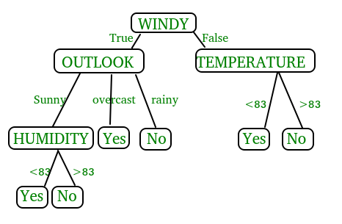
In the above figure, decision tree is a flowchart-like tree structure that is used to make decisions. It consists of Root Node(WINDY), Internal nodes(OUTLOOK, TEMPERATURE), which represent tests on attributes, and leaf nodes, which represent the final decisions. The branches of the tree represent the possible outcomes of the tests.
Key Components of Decision Trees in Python
- Root Node: The decision tree’s starting node, which stands for the complete dataset.
- Branch Nodes: Internal nodes that represent decision points, where the data is split based on a specific attribute.
- Leaf Nodes: Final categorization or prediction-representing terminal nodes.
- Decision Rules: Rules that govern the splitting of data at each branch node.
- Attribute Selection: The process of choosing the most informative attribute for each split.
- Splitting Criteria: Metrics like information gain, entropy, or the Gini Index are used to calculate the optimal split.
Assumptions we make while using Decision tree
- At the beginning, we consider the whole training set as the root.
- Attributes are assumed to be categorical for information gain and for gini index, attributes are assumed to be continuous.
- On the basis of attribute values records are distributed recursively.
- We use statistical methods for ordering attributes as root or internal node
Implementing Decision Tree Using Python:
from sklearn.datasets import load iris
from sklearn.model_selection import train_test_split
from sklearn. Tree import DecisionTreeClassifier
from sklearn.metrics import accuracy_score
# Load the Iris dataset
iris = load_iris()
X = iris.data
y = iris.target
# Split the dataset into training and testing sets
X_train, X_test, y_train, y_test = train_test_split(X, y, test_size=0.2, random_state=42)
# Initialize the decision tree classifier
clf = DecisionTreeClassifier()
# Train the classifier on the training data
clf.fit(X_train, y_train)
# Make predictions on the testing data
y_pred = clf.predict(X_test)
# Calculate the accuracy of the classifier
accuracy = accuracy_score(y_test, y_pred)
print("Accuracy:", accuracy)
In This Example :
- We first import necessary modules from scikit-learn.
- We load the Iris dataset, a popular dataset for classification tasks.
- We split the dataset into training and testing sets using the train test split function.
- We initialize a Decision Tree Classifier.
- We train the classifier on the training data using the fit method.
- We make predictions on the testing data using the predict method.
- Finally, we calculate the accuracy of the classifier using the accuracy score function.
Random Forest:
Machine learning, a fascinating blend of computer science and statistics, has witnessed incredible progress, with one standout algorithm being the Random Forest. Random forests or Random Decision Trees is a collaborative team of decision trees that work together to provide a single output. Originating in 2001 through Leo Breiman, Random Forest has become a cornerstone for machine learning enthusiasts. In this article, we will explore the fundamentals and implementation of Random Forest Algorithm.
Random Forest algorithm is a powerful tree learning technique in Machine Learning. It works by creating a number of Decision Trees during the training phase. Each tree is constructed using a random subset of the data set to measure a random subset of features in each partition. This randomness introduces variability among individual trees, reducing the risk of overfitting and improving overall prediction performance. In prediction, the algorithm aggregates the results of all trees, either by voting (for classification tasks) or by averaging (for regression tasks) This collaborative decision-making process, supported by multiple trees with their insights, provides an example stable and precise results. Random forests are widely used for classification and regression functions, which are known for their ability to handle complex data, reduce overfitting, and provide reliable forecasts in different environments.
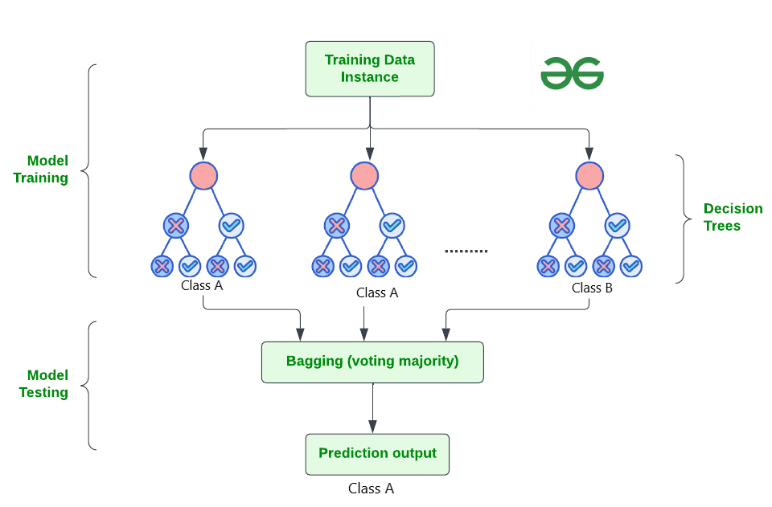

How Does Random Forest Work?
The random Forest algorithm works in several steps which are discussed below–>
- Ensemble of Decision Trees: Random Forest leverages the power of ensemble learning by constructing an army of Decision Trees. These trees are like individual experts, each specializing in a particular aspect of the data. Importantly, they operate independently, minimizing the risk of the model being overly influenced by the nuances of a single tree.
- Random Feature Selection: To ensure that each decision tree in the ensemble brings a unique perspective, Random Forest employs random feature selection. During the training of each tree, a random subset of features is chosen. This randomness ensures that each tree focuses on different aspects of the data, fostering a diverse set of predictors within the ensemble.
- Bootstrap Aggregating or Bagging: The technique of bagging is a cornerstone of Random Forest’s training strategy which involves creating multiple bootstrap samples from the original dataset, allowing instances to be sampled with replacement. This results in different subsets of data for each decision tree, introducing variability in the training process and making the model more robust.
- Decision Making and Voting: When it comes to making predictions, each decision tree in the Random Forest casts its vote. For classification tasks, the final prediction is determined by the mode (most frequent prediction) across all the trees. In regression tasks, the average of the individual tree predictions is taken. This internal voting mechanism ensures a balanced and collective decision-making process.
Key Features of Random Forest
Some of the Key Features of Random Forest are discussed below–>
- High Predictive Accuracy: Imagine Random Forest as a team of decision-making wizards. Each wizard (decision tree) looks at a part of the problem, and together, they weave their insights into a powerful prediction tapestry. This teamwork often results in a more accurate model than what a single wizard could achieve.
- Resistance to Overfitting: Random Forest is like a cool-headed mentor guiding its apprentices (decision trees). Instead of letting each apprentice memorize every detail of their training, it encourages a more well-rounded understanding. This approach helps prevent getting too caught up with the training data which makes the model less prone to overfitting.
- Large Datasets Handling: Dealing with a mountain of data? Random Forest tackles it like a seasoned explorer with a team of helpers (decision trees). Each helper takes on a part of the dataset, ensuring that the expedition is not only thorough but also surprisingly quick.
- Variable Importance Assessment: Think of Random Forest as a detective at a crime scene, figuring out which clues (features) matter the most. It assesses the importance of each clue in solving the case, helping you focus on the key elements that drive predictions.
- Built-in Cross-Validation: Random Forest is like having a personal coach that keeps you in check. As it trains each decision tree, it also sets aside a secret group of cases (out-of-bag) for testing. This built-in validation ensures your model doesn’t just ace the training but also performs well on new challenges.
- Handling Missing Values: Life is full of uncertainties, just like datasets with missing values. Random Forest is the friend who adapts to the situation, making predictions using the information available. It doesn’t get flustered by missing pieces; instead, it focuses on what it can confidently tell us.
- Parallelization for Speed: Random Forest is your time-saving buddy. Picture each decision tree as a worker tackling a piece of a puzzle simultaneously. This parallel approach taps into the power of modern tech, making the whole process faster and more efficient for handling large-scale projects.

Implement Random Forest for Classification :
# Import necessary libraries
import pandas as pd
from sklearn.model_selection import train_test_split
from sklearn.ensemble import RandomForestClassifier
from sklearn.metrics import accuracy_score, classification_report
import warnings
warnings.filterwarnings('ignore')
# Load the Titanic dataset
url = "https://raw.githubusercontent.com/datasciencedojo/datasets/master/titanic.csv"
titanic_data = pd.read_csv(url)
# Drop rows with missing target values
titanic_data = titanic_data.dropna(subset=['Survived'])
# Select relevant features and target variable
X = titanic_data[['Pclass', 'Sex', 'Age', 'SibSp', 'Parch', 'Fare']]
y = titanic_data['Survived']
# Convert categorical variable 'Sex' to numerical using .loc
X.loc[:, 'Sex'] = X['Sex'].map({'female': 0, 'male': 1})
# Handle missing values in the 'Age' column using .loc
X.loc[:, 'Age'].fillna(X['Age'].median(), inplace=True)

# Split the dataset into training and testing sets
X_train, X_test, y_train, y_test = train_test_split(X, y, test_size=0.2, random_state=42)
# Create a Random Forest Classifier
rf_classifier = RandomForestClassifier(n_estimators=100, random_state=42)
# Train the classifier
rf_classifier.fit(X_train, y_train)
# Make predictions on the test set
y_pred = rf_classifier.predict(X_test)
# Evaluate the model
accuracy = accuracy_score(y_test, y_pred)
classification_rep = classification_report(y_test, y_pred)
# Print the results
print(f"Accuracy: {accuracy:.2f}")
print("\nClassification Report:\n", classification_rep)
Output:
Accuracy: 0.80

Classification Report:
precision recall f1-score support

0 0.82 0.85 0.83 105
1 0.77 0.73 0.75 74

accuracy 0.80 179
macro avg 0.79 0.79 0.79 179
weighted avg 0.80 0.80 0.80 179

In the above code, we’re using a Random Forest Classifier to make sense of the Titanic dataset. First, we gather our tools – importing libraries to handle data and evaluate our model. Next, we dive into the Titanic dataset, fixing missing information and choosing important details like a detective solving a mystery. We even teach the computer to understand ‘male’ and ‘female’ by turning them into numbers. Then, we split our dataset into pieces – one part to train our model, and the other to test its newfound skills. Our Random Forest Classifier is like a student, learning from the training set. Once trained, it faces a test – making predictions on the test set. We’re like judges, using a classification report to grade how well our model did.
Convolutional Neural Network (CNN)
A Convolutional Neural Network (CNN) is a type of Deep Learning neural network architecture commonly used in Computer Vision. Computer vision is a field of Artificial Intelligence that enables a computer to understand and interpret the image or visual data.
When it comes to Machine Learning, Artificial Neural Networks perform really well. Neural Networks are used in various datasets like images, audio, and text. Different types of Neural Networks are used for different purposes, for example for predicting the sequence of words we use Recurrent Neural Networks more precisely an LSTM, similarly for image classification we use Convolution Neural networks. In this blog, we are going to build a basic building block for CNN.
In a regular Neural Network there are three types of layers:
- Input Layers: It’s the layer in which we give input to our model. The number of neurons in this layer is equal to the total number of features in our data (number of pixels in the case of an image).
- Hidden Layer: The input from the Input layer is then fed into the hidden layer. There can be many hidden layers depending on our model and data size. Each hidden layer can have different numbers of neurons which are generally greater than the number of features. The output from each layer is computed by matrix multiplication of the output of the previous layer with learnable weights of that layer and then by the addition of learnable biases followed by activation function which makes the network nonlinear.
- Output Layer: The output from the hidden layer is then fed into a logistic function like sigmoid or softmax which converts the output of each class into the probability score of each class.
The data is fed into the model and output from each layer is obtained from the above step is called feedforward, we then calculate the error using an error function, some common error functions are cross-entropy, square loss error, etc. The error function measures how well the network is performing. After that, we backpropagate into the model by calculating the derivatives. This step is called Backprzopagation which basically is used to minimize the loss.

Convolution Neural Network
Convolutional Neural Network (CNN) is the extended version of artificial neural networks (ANN) which is predominantly used to extract the feature from the grid-like matrix dataset. For example visual datasets like images or videos where data patterns play an extensive role.

CNN architecture
Convolutional Neural Network consists of multiple layers like the input layer, Convolutional layer, Pooling layer, and fully connected layers.
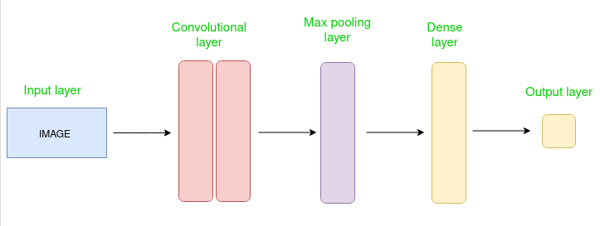
Simple CNN architecture
The Convolutional layer applies filters to the input image to extract features, the Pooling layer downsamples the image to reduce computation, and the fully connected layer makes the final prediction. The network learns the optimal filters through backpropagation and gradient descent.

How Convolutional Layers works
Convolution Neural Networks or covnets are neural networks that share their parameters. Imagine you have an image. It can be represented as a cuboid having its length, width (dimension of the image), and height (i.e the channel as images generally have red, green, and blue channels).
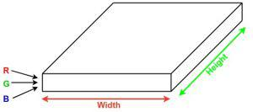
Now imagine taking a small patch of this image and running a small neural network, called a filter or kernel on it, with say, K outputs and representing them vertically. Now slide that neural network across the whole image, as a result, we will get another image with different widths, heights, and depths. Instead of just R, G, and B channels now we have more channels but lesser width and height. This operation is called Convolution. If the patch size is the same as that of the image it will be a regular neural network. Because of this small patch, we have fewer weights.
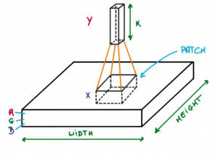
Image source: Deep Learning Udacity
Now let’s talk about a bit of mathematics that is involved in the whole convolution process.
- Convolution layers consist of a set of learnable filters (or kernels) having small widths and heights and the same depth as that of input volume (3 if the input layer is image input).
- For example, if we have to run convolution on an image with dimensions 34x34x3. The possible size of filters can be axax3, where ‘a’ can be anything like 3, 5, or 7 but smaller as compared to the image dimension.
- During the forward pass, we slide each filter across the whole input volume step by step where each step is called stride (which can have a value of 2, 3, or even 4 for high-dimensional images) and compute the dot product between the kernel weights and patch from input volume.
- As we slide our filters we’ll get a 2-D output for each filter and we’ll stack them together as a result, we’ll get output volume having a depth equal to the number of filters. The network will learn all the filters.

Layers used to build ConvNets
A complete Convolution Neural Networks architecture is also known as covnets. A covnets is a sequence of layers, and every layer transforms one volume to another through a differentiable function.
Types of layers:
datasets
Let’s take an example by running a covnets on of image of dimension 32 x 32 x 3.
- Input Layers: It’s the layer in which we give input to our model. In CNN, Generally, the input will be an image or a sequence of images. This layer holds the raw input of the image with width 32, height 32, and depth 3.
- Convolutional Layers: This is the layer, which is used to extract the feature from the input dataset. It applies a set of learnable filters known as the kernels to the input images. The filters/kernels are smaller matrices usually 2×2, 3×3, or 5×5 shape. it slides over the input image data and computes the dot product between kernel weight and the corresponding input image patch. The output of this layer is referred as feature maps. Suppose we use a total of 12 filters for this layer we’ll get an output volume of dimension 32 x 32 x 12.
- Activation Layer: By adding an activation function to the output of the preceding layer, activation layers add nonlinearity to the network. it will apply an element-wise activation function to the output of the convolution layer. Some common activation functions are RELU: max(0, x), Tanh, Leaky RELU, etc. The volume remains unchanged hence output volume will have dimensions 32 x 32 x 12.
- Pooling layer: This layer is periodically inserted in the covnets and its main function is to reduce the size of volume which makes the computation fast reduces memory and also prevents overfitting. Two common types of pooling layers are max pooling and average pooling. If we use a max pool with 2 x 2 filters and stride 2, the resultant volume will be of dimension 16x16x12.
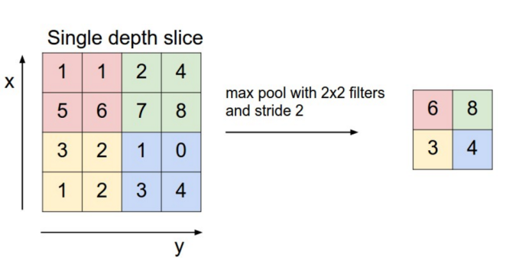
Image source: cs231n.stanford.edu
- Flattening: The resulting feature maps are flattened into a one-dimensional vector after the convolution and pooling layers so they can be passed into a completely linked layer for categorization or regression.
- Fully Connected Layers: It takes the input from the previous layer and computes the final classification or regression task.
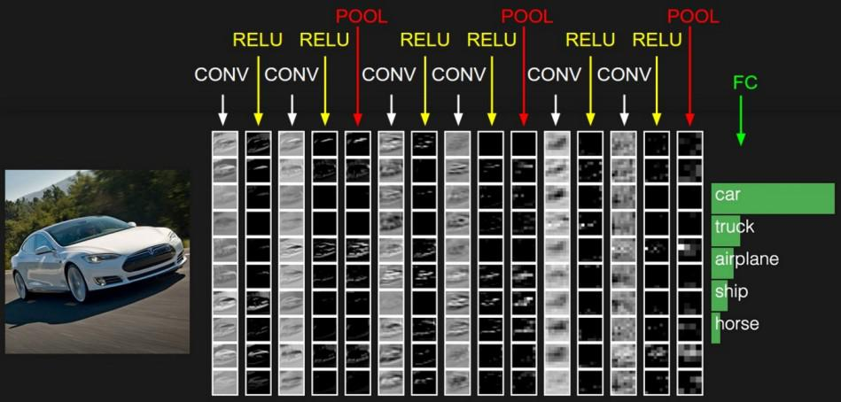
- Output Layer: The output from the fully connected layers is then fed into a logistic function for classification tasks like sigmoid or softmax which converts the output of each class into the probability score of each class.

Example:
Let’s consider an image and apply the convolution layer, activation layer, and pooling layer operation to extract the inside feature.
Input image:

Input image

Step:
- import the necessary libraries
- set the parameter
- define the kernel
- Load the image and plot it.
- Reformat the image
- Apply convolution layer operation and plot the output image.
- Apply activation layer operation and plot the output image.
- Apply pooling layer operation and plot the output image.

Python3
# import the necessary libraries
import numpy as np
import tensorflow as tf
import matplotlib.pyplot as plt
from itertools import product
# set the param
plt.rc('figure', autolayout=True)
plt.rc('image', cmap='magma')

# define the kernel
kernel = tf.constant([[-1, -1, -1],
[-1, 8, -1],
[-1, -1, -1],
])

# load the image
image = tf.io.read_file('Ganesh.jpg')
image = tf.io.decode_jpeg(image, channels=1)
image = tf.image.resize(image, size=[300, 300])

# plot the image
img = tf.squeeze(image).numpy()
plt.figure(figsize=(5, 5))
plt.imshow(img, cmap='gray')
plt.axis('off')
plt.title('Original Gray Scale image')
plt.show();

# Reformat
image = tf.image.convert_image_dtype(image, dtype=tf.float32)
image = tf.expand_dims(image, axis=0)
kernel = tf.reshape(kernel, [*kernel.shape, 1, 1])
kernel = tf.cast(kernel, dtype=tf.float32)

# convolution layer
conv_fn = tf.nn.conv2d

image_filter = conv_fn(
input=image,
filters=kernel,
strides=1, # or (1, 1)
padding='SAME',
)

plt.figure(figsize=(15, 5))

# Plot the convolved image
plt.subplot(1, 3, 1)

plt.imshow(
tf.squeeze(image_filter)
)
plt.axis('off')
plt.title('Convolution')

# activation layer
relu_fn = tf.nn.relu
# Image detection
image_detect = relu_fn(image_filter)

plt.subplot(1, 3, 2)
plt.imshow(
# Reformat for plotting
tf.squeeze(image_detect)
)

plt.axis('off')
plt.title('Activation')

# Pooling layer
pool = tf.nn.pool
image_condense = pool(input=image_detect,
window_shape=(2, 2),
pooling_type='MAX',
strides=(2, 2),
padding='SAME',
)

plt.subplot(1, 3, 3)
plt.imshow(tf.squeeze(image_condense))
plt.axis('off')
plt.title('Pooling')
plt.show()
Output:

Original Grayscale image
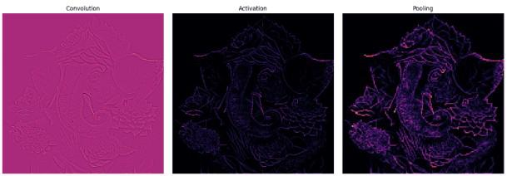
5.2 Sample Code:
ExpensesPrediction.ipynb
#importing all required python libraries
import pandas as pd
import numpy as np
import matplotlib.pyplot as plt
from sklearn.model_selection import train_test_split
from sklearn.preprocessing import MinMaxScaler
import matplotlib.pyplot as plt #use to visualize dataset values
import seaborn as sns
from sklearn.metrics import mean_squared_error
from math import sqrt
from sklearn.metrics import r2_score
from sklearn.preprocessing import LabelEncoder
from sklearn.ensemble import RandomForestRegressor
from sklearn.tree import DecisionTreeRegressor
import os
from keras.models import Sequential, load_model
from keras.layers import Dense, Activation
from keras.layers import Dropout
from keras.callbacks import ModelCheckpoint
from keras.layers import MaxPooling2D
from keras.layers import Flatten
from keras.layers import Convolution2D
import pickle
from sklearn.preprocessing import MinMaxScaler
#class to normalize dataset values
scaler = MinMaxScaler(feature_range = (0, 1))
scaler1 = MinMaxScaler(feature_range = (0, 1))
#loading and displaying dataset values
import pandas as pd
dataset = pd.read_excel("D:/Expenses Prediction/Dataset/Expenses.xlsx",engine='openpyxl')
dataset.fillna(0, inplace = True)
dataset
#displaying different expenses category found in dataset
import numpy as np
# Convert the 'Expenses' column to string (or handle NaNs if necessary)
dataset['Expenses'] = dataset['Expenses'].astype(str)
# Get unique expense categories
expenses_category = np.unique(dataset['Expenses'])
# Print the categories
for i in range(len(expenses_category)):
print(f"Category ID = {i+1} Category Expenses Name = {expenses_category[i]}")
#finding and displaying count of missing or null values from each column
dataset.isnull().sum()
import matplotlib.pyplot as plt # Correct import for pyplot
# Grouping the data by Expenses and summing the Amount
data = dataset.groupby(["Expenses"])['Amount'].sum().reset_index()
# Plotting the data
data.plot(x="Expenses", y="Amount", kind="bar", figsize=(8, 3))
# Adding a title to the plot
plt.title('Amount Spent on Different Expenses')
# Displaying the plot
plt.show()
#Visualizing graph of amount spend on different Dates
import matplotlib.pyplot as plt
import pandas as pd
dataset['Date'] = pd.to_datetime(dataset['Date'], errors='coerce')
dataset = dataset.dropna(subset=['Date'])
data = dataset.groupby(['Date'])['Amount'].sum().reset_index()
plt.figure(figsize=(6, 4))
plt.plot(data['Date'], data['Amount'])
plt.title('Highest Amount Expenditure Dates')
plt.xlabel('Date')
plt.ylabel('Amount')
plt.show()
#visualizing graph of amount spent on different categories
import matplotlib.pyplot as plt
import pandas as pd
plt.figure(figsize=(6, 4))
import seaborn as sns
sns.boxplot(x="Category", y="Amount", data=dataset)
plt.title('Category Wise Expenditure')
plt.xlabel('Category')
plt.ylabel('Amount')
plt.grid(True, which='both', linestyle='--', linewidth=0.5)
plt.tight_layout()
plt.show()
# visualizing graph of total expenses done at different Province
data = dataset.groupby(["Province"]) ['Amount' ].sum().reset_index()
plt.pie(data['Amount'], labels=data['Province'], autopct='%1.1f%%')
plt.title('Province Wise Expenditure' )
plt.show()
from sklearn.preprocessing import LabelEncoder
#dataset peprocessing converting datetime to numeric values and non-numeric values to numeric values
dataset['Date'] = pd.to_datetime(dataset['Date' ])
dataset['year' ] = dataset['Date'].dt.year
dataset['month'] = dataset['Date'].dt.month
dataset['day'] = dataset['Date'].dt.day
label_encoder = []
columns = dataset.columns
types = dataset.dtypes.values
for i in range(len(types)):
name = types[i]
if name == 'object': #finding column with object type
le = LabelEncoder()
dataset[columns[i]] = pd.Series(le.fit_transform(dataset[columns[i]].astype(str)))#encode all str columns to numeric
label_encoder.append([columns[i], le])
#handling and removing missing values
dataset.drop(['Date'], axis = 1,inplace=True)#drop ir-relevant columns
dataset.fillna(0, inplace = True)
print("Cleaned Dataset Values")
dataset
from sklearn.preprocessing import MinMaxScaler
if 'Amount' in dataset.columns:
Y = dataset['Amount'].values.reshape(-1, 1) # Get the Amount values for Y (target variable)
dataset.drop(['Amount'], axis=1, inplace=True) # Drop the 'Amount' column from the dataset
else:
print("'Amount' column is not found in the dataset.")
X = dataset.values
scaler = MinMaxScaler()
scaler1 = MinMaxScaler()
X = scaler.fit_transform(X)
Y = scaler1.fit_transform(Y)
print("Normalized Features = " + str(X))
from sklearn.model_selection import train_test_split
import numpy as np
# Split the data into training and testing datasets
X_train, X_test, y_train, y_test = train_test_split(X, Y, test_size=0.2)
# Print the information about the dataset split
print("Train & Test Dataset Split")
print("Total records found in dataset = " + str(X.shape[0]))
print("Total features found in dataset = " + str(X.shape[1]))
print("80% records used to train AI Algorithms : " + str(X_train.shape[0]))
print("20% records used to AI Algorithms : " + str(X_test.shape[0]))
# If you still want to save and load data, you can use the following:
# Save the data (for example, saving the train and test data as a numpy array):
np.save('model/data.npy', (X_train, X_test, y_train, y_test))
# If you need to load it again later, use this (assuming file exists):
# data = np.load("model/data.npy", allow_pickle=True)
# X_train, X_test, y_train, y_test = data
#defining global variables to save algorithm performnace metrics
rsquare = []
mse = []
rmse = []
#function to calculate MAPE, RMSE and R2Square from predicted and true values
global test_label,r2_score,sqrt
from sklearn.metrics import mean_squared_error
from sklearn.metrics import r2_score

def calculateMetrics(algorithm, predict, test_labels):
mse_error = mean_squared_error(test_labels, predict)
predict = predict.reshape(-1, 1)
predict = scaler1.inverse_transform(predict)
test_label = scaler1.inverse_transform(test_labels)
predict = predict.ravel()
test_label = test_label.ravel()
r2_scores = r2_score(test_label, predict)
rmse_error = sqrt(mse_error)
rsquare.append(r2_scores)
mse.append(mse_error)
rmse.append(rmse_error)
print()
print(algorithm+" MSE : "+str(mse_error))
print(algorithm+" RMSE : "+str(rmse_error))
print(algorithm+" R2 : "+str(r2_scores))
print()
plt.plot(test_label, color = 'red', label = 'True Expenses')
plt.plot(predict, color = 'green', label = 'Predicted Expenses')
plt.title(algorithm+'Expenditure Forecasting Graph')
plt.xlabel('Number Of Test Samples')
plt.ylabel('Expenditure Forecasting')
plt.legend()
plt.show()
for i in range(0, 10):
print("True Expenditure Amount : "+str(test_label[i])+" Predicted Expenditure Amount : "+str(predict[i]))
#training Random Forest algorithm on training features and evaluating regression performance on test data
rf_cls = RandomForestRegressor()
rf_cls.fit(X_train, y_train.ravel())
#perform prediction on test datat
predict = rf_cls.predict(X_test)
#call this function to calculate performance metrics
calculateMetrics("Random Forest", predict, y_test)
#training propose AM-CTP Linear Regression algorithm
dt_cls = DecisionTreeRegressor()
dt_cls.fit(X_train, y_train.ravel())
#perform prediction on test datat
predict = dt_cls.predict(X_test)
#call this function to calculate performance metrics
calculateMetrics("Decision Tree", predict, y_test)
from keras.models import Sequential
from keras.layers import Convolution2D, MaxPooling2D, Flatten, Dense
from keras.callbacks import ModelCheckpoint
import os
# Reshaping the data for CNN input
X_train1 = np.reshape(X_train, (X_train.shape[0], X_train.shape[1], 1, 1))
X_test1 = np.reshape(X_test, (X_test.shape[0], X_test.shape[1], 1, 1))
# Create CNN model
cnn_model = Sequential()
cnn_model.add(Convolution2D(32, (1, 1), input_shape=(X_train1.shape[1], X_train1.shape[2], X_train1.shape[3]), activation='relu'))
cnn_model.add(MaxPooling2D(pool_size=(1, 1)))
cnn_model.add(Convolution2D(32, (1, 1), activation='relu'))
cnn_model.add(MaxPooling2D(pool_size=(1, 1)))
cnn_model.add(Flatten())
cnn_model.add(Dense(units=64, activation='relu'))
cnn_model.add(Dense(units=1))
# Compile the CNN model
cnn_model.compile(optimizer='adam', loss='mean_squared_error')
# Check if the model weights file exists, if not, train the model
if not os.path.exists("model/cnn_weights.hdf5"):
model_check_point = ModelCheckpoint(filepath='model/cnn_weights.hdf5', verbose=1, save_best_only=True)
cnn_model.fit(X_train1, y_train, batch_size=16, epochs=100, validation_data=(X_test1, y_test), callbacks=[model_check_point])
else:
cnn_model.load_weights("model/cnn_weights.hdf5")
# Perform prediction
predict = cnn_model.predict(X_test1)
# Call the function to calculate metrics
calculateMetrics("CNN", predict, y_test)
global test_label,r2_scores,sqrt
from sklearn.metrics import r2_score
df = pd.DataFrame([['Random Forest','R2Score',rsquare[0]],
['Decision Tree','R2Score',rsquare[1]],
['CNN Algorithm','R2Score',rsquare[2]],
],columns=['Parameters','Algorithms','Value'])
df.pivot("Parameters", "Algorithms", "Value").plot(kind='bar')
plt.title("All Algorithm Performance Graph")
plt.show()
#display all algorithm performnace in tabular format
algorithms = ['Random Forest', 'Decision Tree', 'CNN']
data = []
for i in range(len(rmse)):
data.append([algorithms[i], rsquare[i], rmse[i], mse[i]])
data = pd.DataFrame(data, columns=['Algorithm Name', 'R2 Score', 'RMSE', 'MSE' ])
data
#read test values from test dataset file and then predict cellular traffic demand
test_data = pd.read_excel("D:/Expenses Prediction/Dataset/testData.xlsx",engine='openpyxl')
test_data.fillna(0, inplace = True)
temp = test_data.values
test_data['Date'] = pd.to_datetime(test_data['Date'])#convert datetime to numeric format
test_data['year'] = test_data['Date'].dt.year
test_data['month'] = test_data['Date'].dt.month
test_data['day'] = test_data['Date'].dt.day
test_data.drop(['Date'], axis = 1,inplace=True)
for i in range(len(label_encoder)):
le = label_encoder[i]
test_data[le[0]] = pd.Series(le[1].transform(test_data[le[0]].astype(str)))#encode all str columns to numeric
#handling and removing missing values
test_data.fillna(0, inplace = True)
test_data = test_data.values
test_data = scaler.transform(test_data)#select features using select k-best
predict = dt_cls.predict(test_data)#perform prediction using XGBOOST on test data
predict = predict.reshape(-1, 1)
predict = scaler1.inverse_transform(predict)#denormalize pedicted demand
for i in range(len(predict)):
print("Test Data = "+str(temp[i])+" Future Forecasted Expenses = "+str(predict[i,0]))
print()
def recommendation(svd_model, item, top_n_community = 5):
index = item - 1
row = svd_model[index, :]
magnitude = np.sqrt(np.einsum('ij, ij -> i', svd_model, svd_model))
similarity = np.dot(row, svd_model.T) / (magnitude[index] * magnitude)
sort_indexes = np.argsort(-similarity)
return sort_indexes[:top_n_community]
import pandas as pd
import numpy as np
# Read dataset
dataset = pd.read_excel("D:/Expenses Prediction/Dataset/Expenses.xlsx", engine='openpyxl')
# Check data types and see if there are mixed types in the 'Expenses' column
print(dataset['Expenses'].dtype)
# Convert 'Expenses' to string to ensure uniformity
dataset['Expenses'] = dataset['Expenses'].astype(str)
# Now, use np.unique to get unique expenses
expenses = np.unique(dataset['Expenses'].ravel())
# Continue with the rest of your processing
dataset['Date'] = pd.to_datetime(dataset['Date'])
dataset['Day'] = dataset['Date'].dt.dayofyear
# Pivot the dataset
dataset = pd.pivot_table(dataset, values='Amount', index='Expenses', columns='Day')
dataset.fillna(0, inplace=True)
# Perform SVD
u, s, svd_matrix = np.linalg.svd(dataset, full_matrices=False)
print("Recommendation Model Generated")
global recommendation
category_id = input("Please Expenses Category ID for Recommendation : ")
category_id = int(category_id)
recommend = recommendation(svd_matrix, category_id)
print("Recommended Expenses List\n")
for i in range(len(recommend)):
print(expenses[recommend[i]])
6. TESTING
Implementation and Testing:
Implementation is one of the most important tasks in project is the phase in which one has to be cautions because all the efforts undertaken during the project will be very interactive. Implementation is the most crucial stage in achieving successful system and giving the users confidence that the new system is workable and effective. Each program is tested individually at the time of development using the sample data and has verified that these programs link together in the way specified in the program specification. The computer system and its environment are tested to the satisfaction of the user.

Implementation

The implementation phase is less creative than system design. It is primarily concerned with user training, and file conversion. The system may be requiring extensive user training. The initial parameters of the system should be modifies as a result of a programming. A simple operating procedure is provided so that the user can understand the different functions clearly and quickly. The different reports can be obtained either on the inkjet or dot matrix printer, which is available at the disposal of the user. The proposed system is very easy to implement. In general implementation is used to mean the process of converting a new or revised system design into an operational one.

Testing
Testing is the process where the test data is prepared and is used for testing the modules individually and later the validation given for the fields. Then the system testing takes place which makes sure that all components of the system property functions as a unit. The test data should be chosen such that it passed through all possible condition. Actually testing is the state of implementation which aimed at ensuring that the system works accurately and efficiently before the actual operation commence. The following is the description of the testing strategies, which were carried out during the testing period.

System Testing
Testing has become an integral part of any system or project especially in the field of information technology. The importance of testing is a method of justifying, if one is ready to move further, be it to be check if one is capable to with stand the rigors of a particular situation cannot be underplayed and that is why testing before development is so critical. When the software is developed before it is given to user to use the software must be tested whether it is solving the purpose for which it is developed. This testing involves various types through which one can ensure the software is reliable. The program was tested logically and pattern of execution of the program for a set of data are repeated. Thus the code was exhaustively checked for all possible correct data and the outcomes were also checked.

Module Testing
To locate errors, each module is tested individually. This enables us to detect error and correct it without affecting any other modules. Whenever the program is not satisfying the required function, it must be corrected to get the required result. Thus all the modules are individually tested from bottom up starting with the smallest and lowest modules and proceeding to the next level. Each module in the system is tested separately. For example the job classification module is tested separately. This module is tested with different job and its approximate execution time and the result of the test is compared with the results that are prepared manually. The comparison shows that the results proposed system works efficiently than the existing system. Each module in the system is tested separately. In this system the resource classification and job scheduling modules are tested separately and their corresponding results are obtained which reduces the process waiting time.
Integration Testing
After the module testing, the integration testing is applied. When linking the modules there may be chance for errors to occur, these errors are corrected by using this testing. In this system all modules are connected and tested. The testing results are very correct. Thus the mapping of jobs with resources is done correctly by the system.
Acceptance Testing
When that user fined no major problems with its accuracy, the system passers through a final acceptance test. This test confirms that the system needs the original goals, objectives and requirements established during analysis without actual execution which elimination wastage of time and money acceptance tests on the shoulders of users and management, it is finally acceptable and ready for the operation
Test Case Id | Test Case Name | Test Case Desc. | Test Steps |  |  | Test Case Status | Test Priority
 |  |  | Step | Expected | Actual
01 | Upload Dataset | Test whether Dataset is uploaded or not into the system | If the Dataset may not uploaded | We cannot do further operations | Dataset uploaded we will do further operations | High | High
02 | Preprocess& Normalized Dataset | Test whether the Pre-process & Normalized Dataset Successfully or not | If the Pre-process & Normalized Dataset may not Run Successfully | We cannot do further operations | we will do further  operations | High | High
03 | Run Random Forest | Test whether Random Forest Algorithm Run Successfully or not | If the Random Forest Algorithm may not Run Successfully | We cannot do further operations | we will do further  operations | High | High
04 | Run Decision Tree | Test whether Decision Tree Algorithm Run Successfully or not | If the Decision Tree Algorithm may not Run Successfully | We cannot do further operations | we will do further  operations | High | High
05 | Run CNN | Test whether CNN Algorithm Run Successfully or not | If the CNN Algorithm may not Run Successfully | We cannot do further operations | we will do further  operations | High | High
06 | Prediction | Test whether Test data Uploaded Successfully or not | If the Test data may not uploaded Successfully | We cannot do further operations | we will do further  operations | High | High

7.SCREENSHOTS:
We have coded this project using JUPYTER notebook and below are the code and output screens with blue colour comments
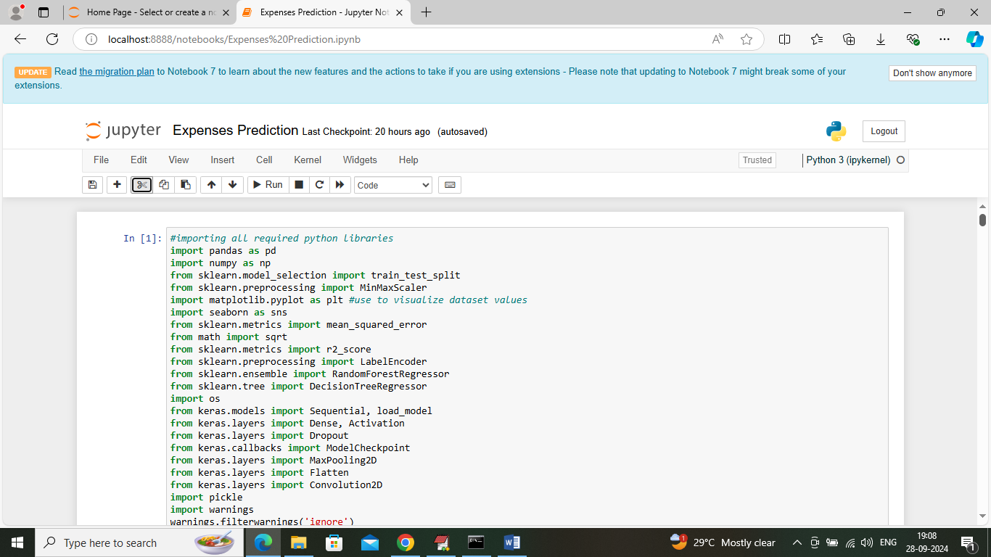
In above screen importing required python classes and packages
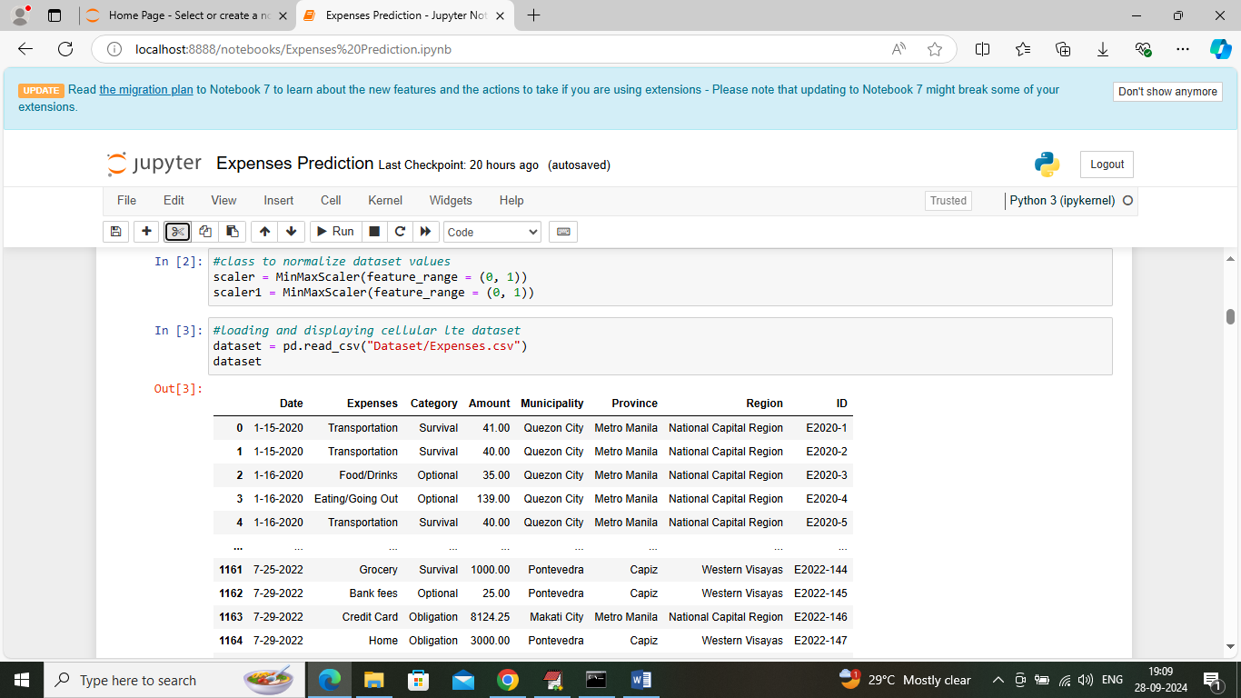
In above screen loading and displaying dataset values
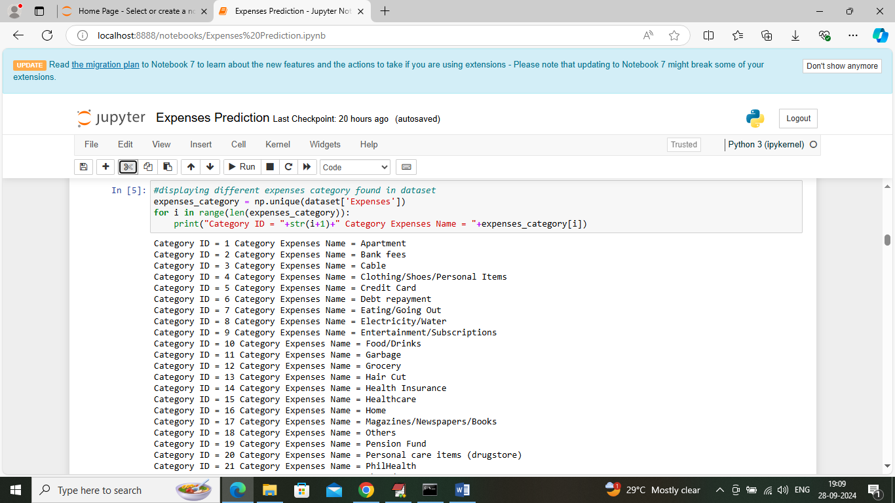
In above screen displaying category Id along with expenses category names and while recommendation you can enter any category ID and then application will recommend other category expenses names.
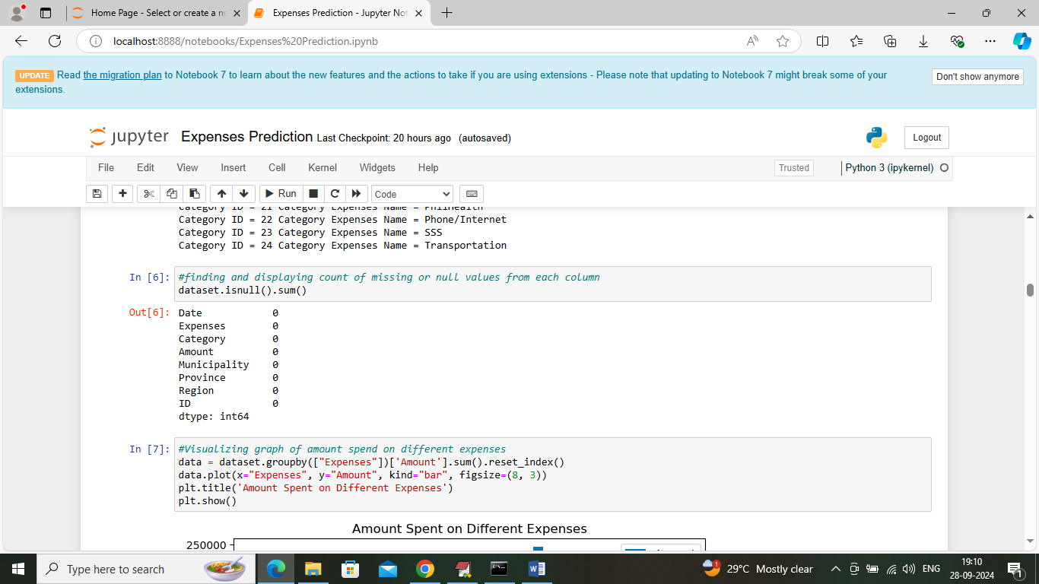
In above screen finding and displaying count of missing values in dataset but above dataset contains 0 missing values count
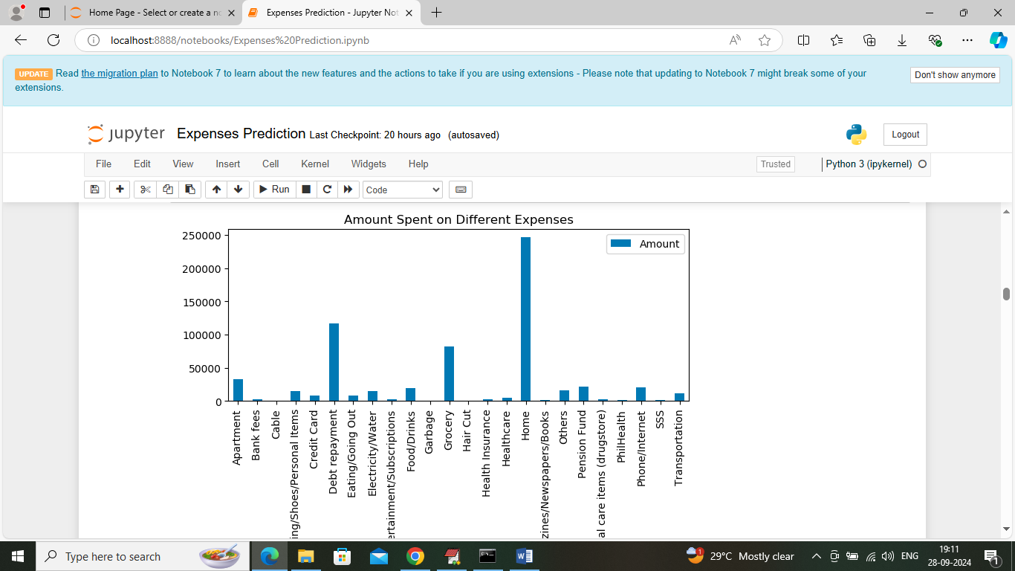
In above screen visualizing total amount spent on different expenses category where x-axis represents category names and y-axis represents expenses amount
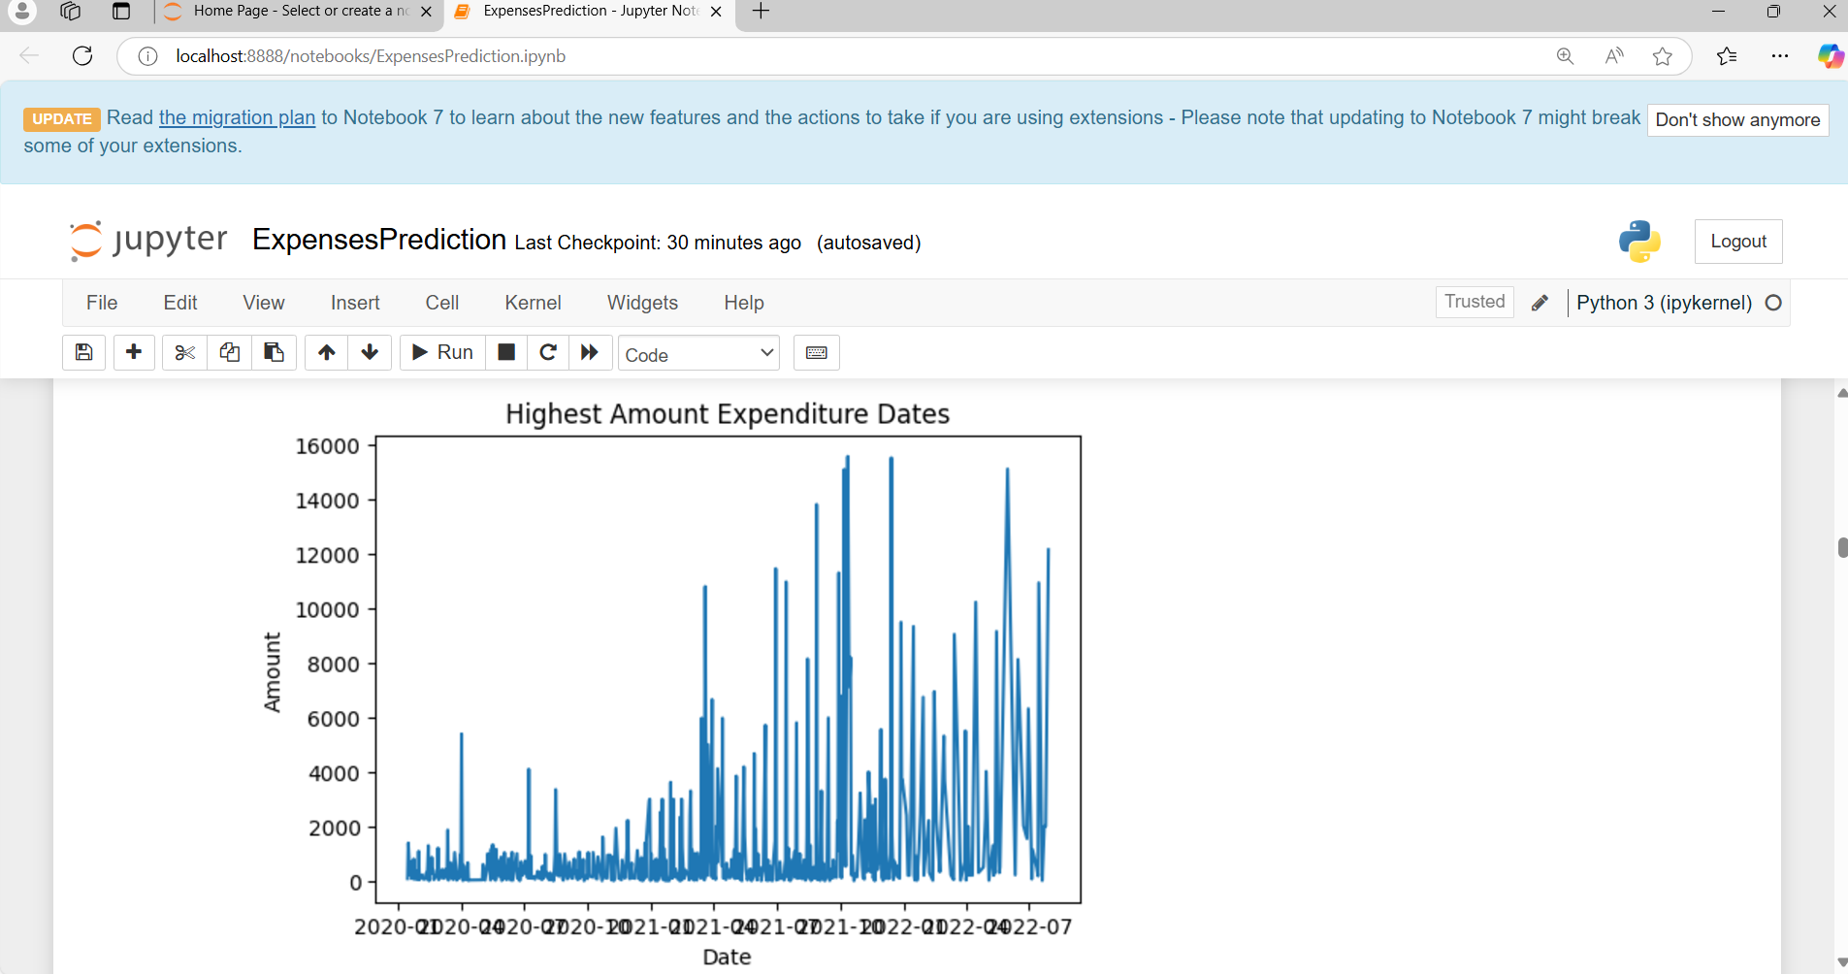
In above screen visualizing expenditure graph based on date where x-axis represents Date and y-axis represents amount

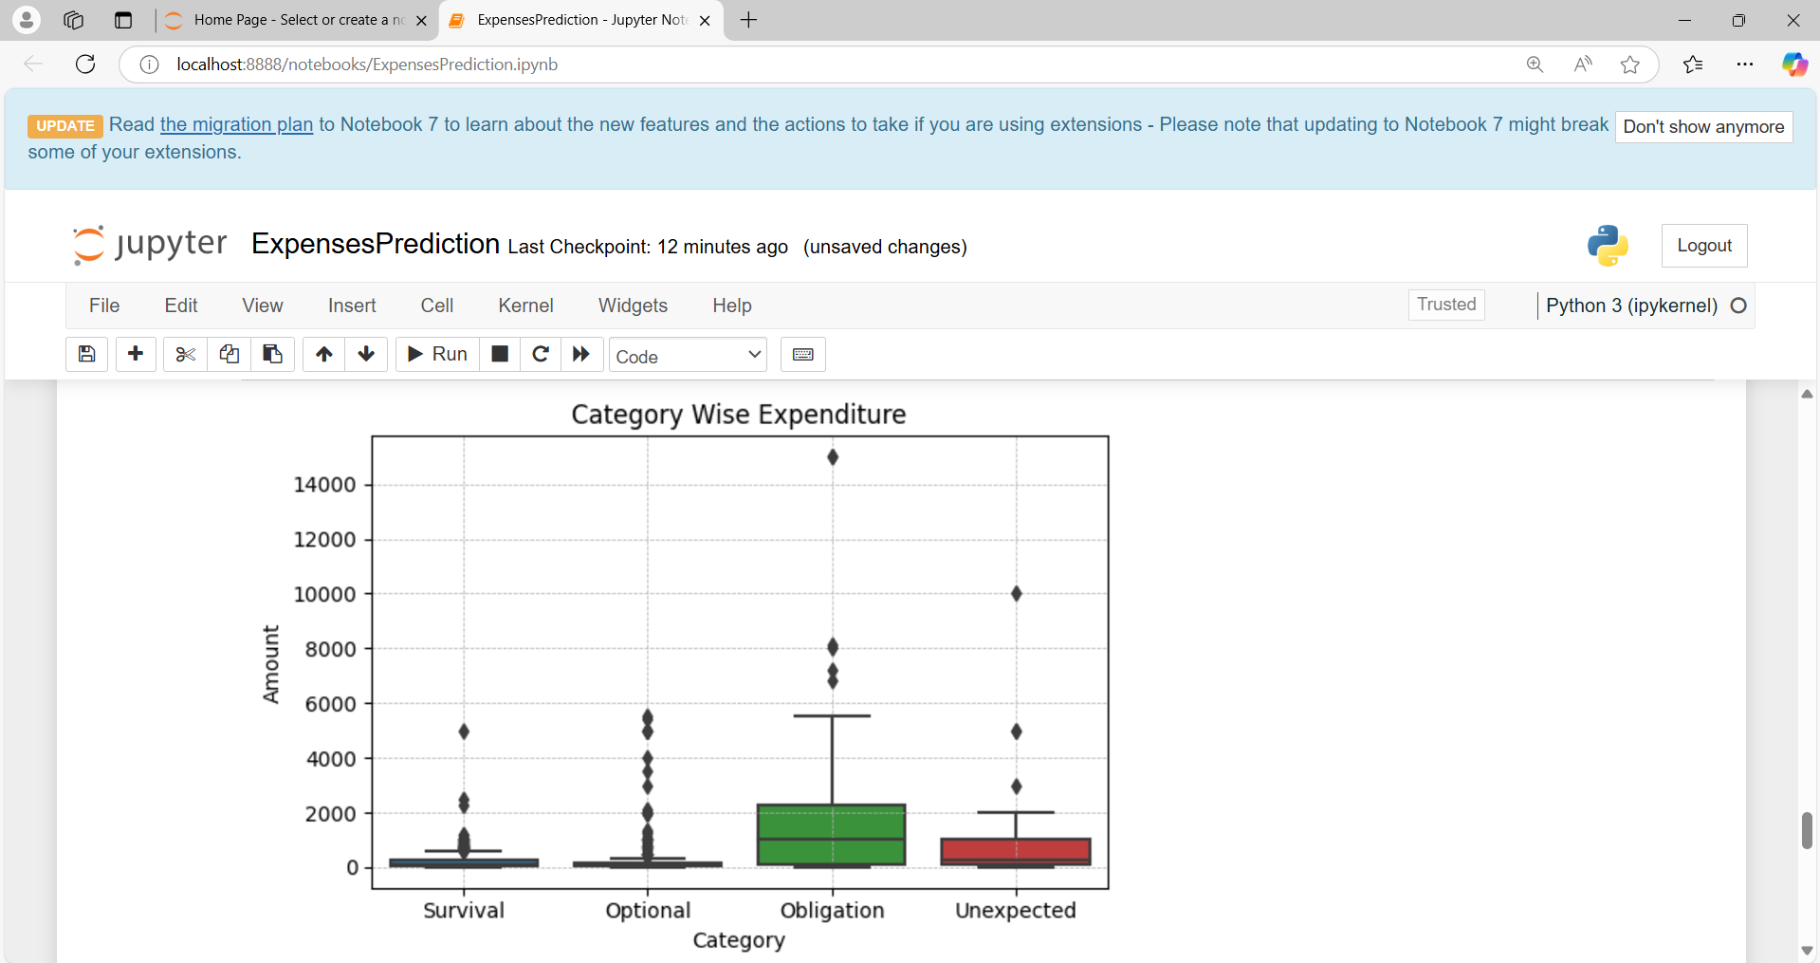
In above screen visualizing graph of amount spent on different categories where x-axis represents category name and y-axis represent amount
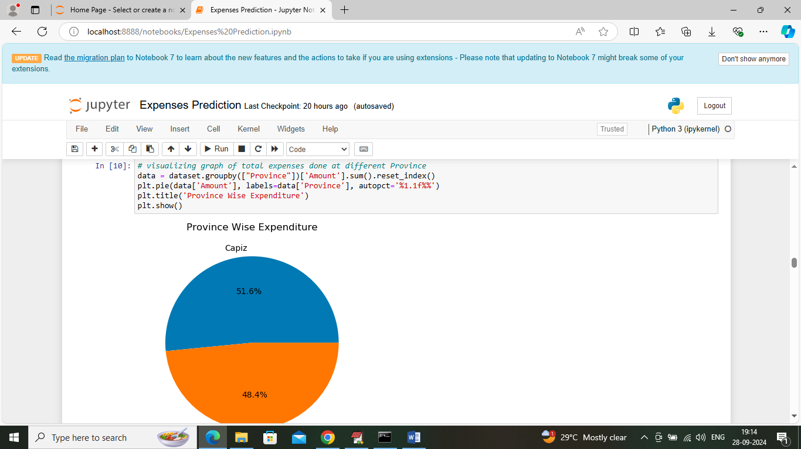
In above screen visualizing graph of total amount spent on different area or province
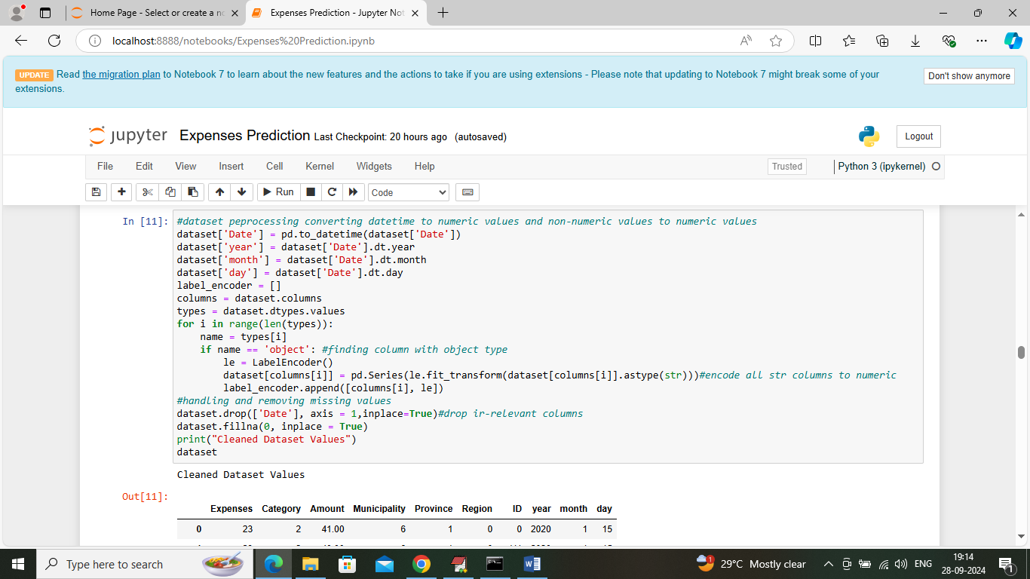
In above screen applying dataset label encoding to convert all non-numeric values to numeric values and after conversion will get below output
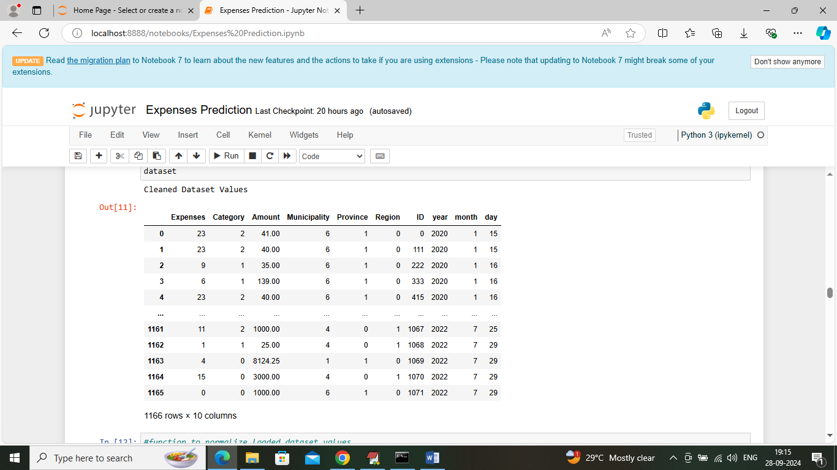
In above screen entire dataset columns converted to numeric format
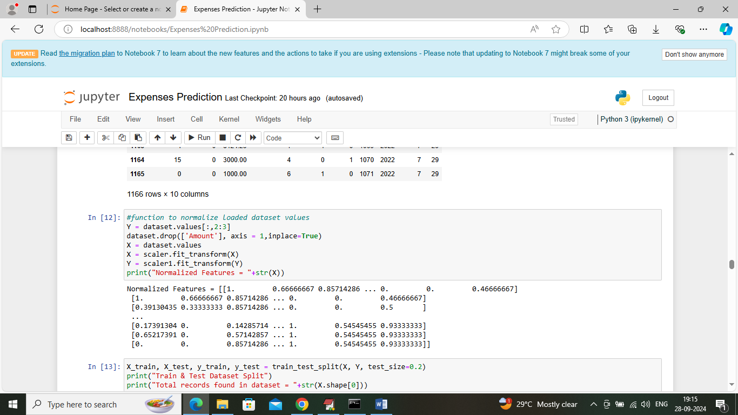
In above screen applying MINMAX algorithm to normalize dataset values
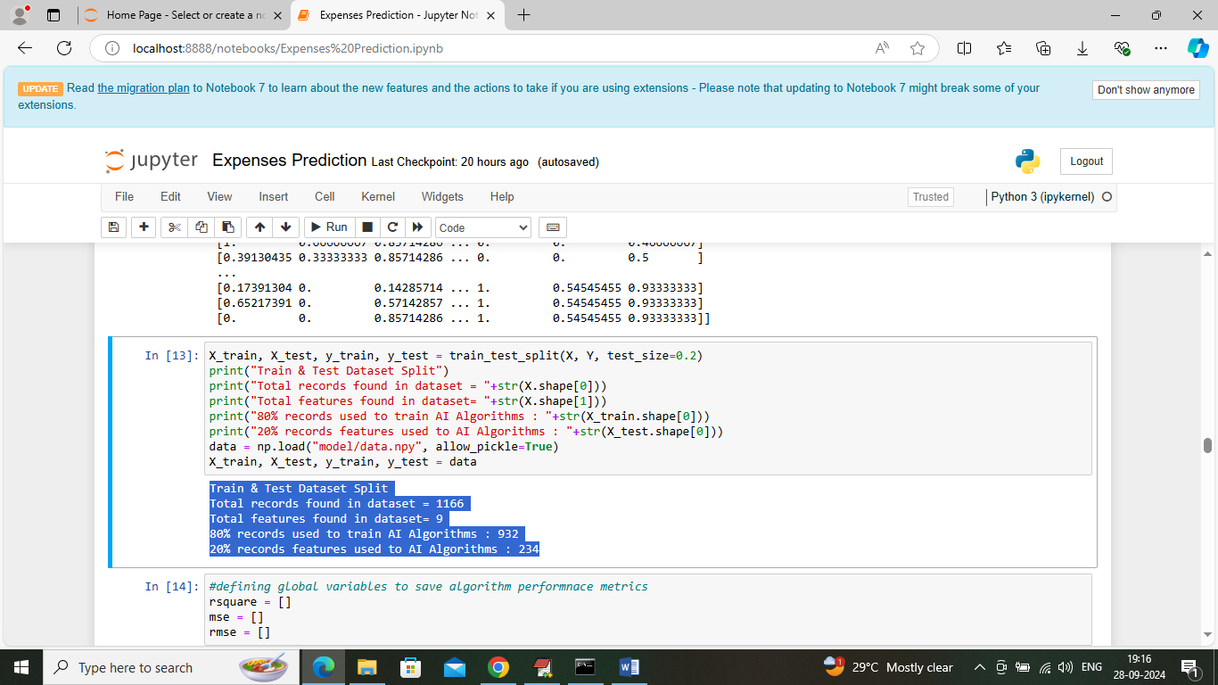
In above screen splitting entire dataset into train and test where application using 80% dataset for training and then apply trained model on 20% test data to calculate prediction R2score accuracy
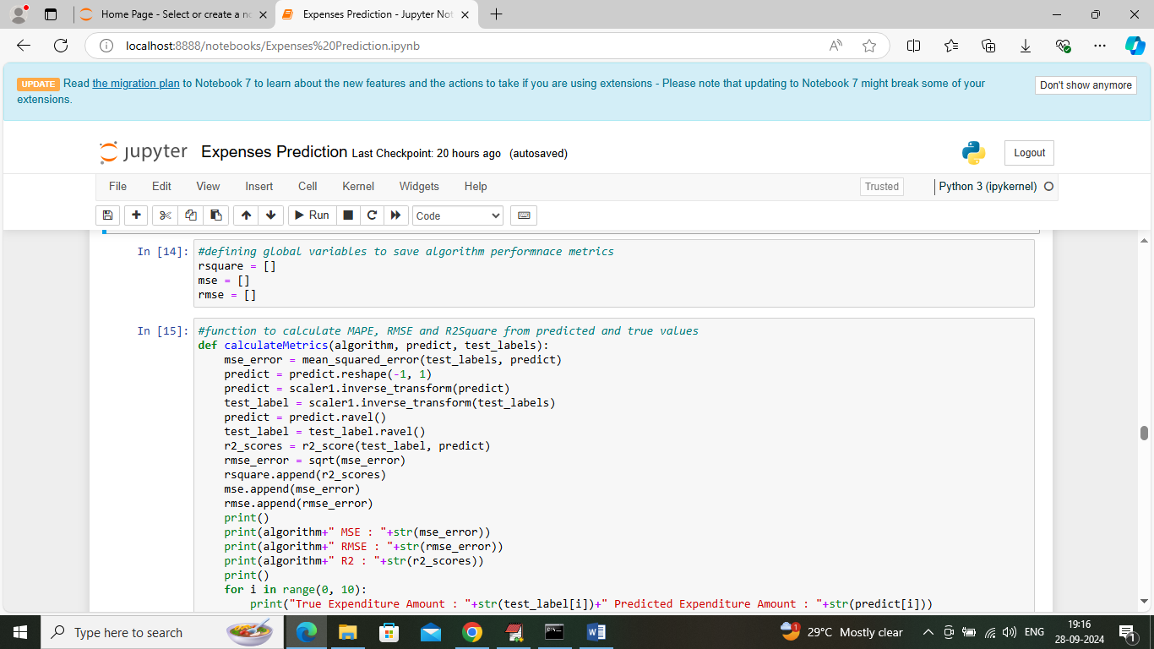
In above screen defining function to calculate RMSE, MSE and other metrics
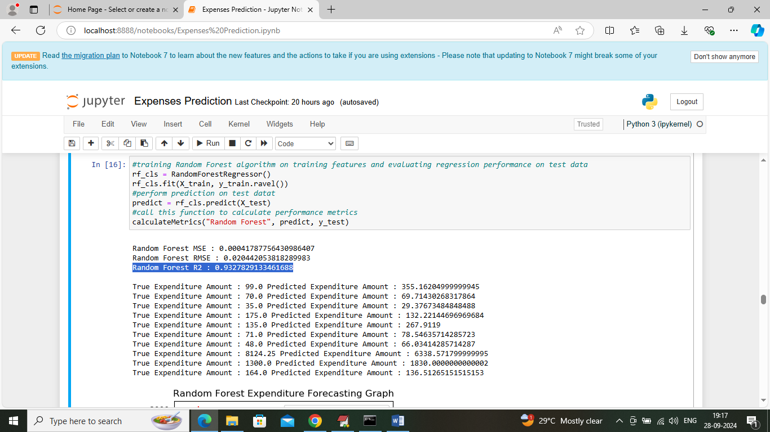
In above screen training random forest algorithm on training data and then applying 20% test data on trained model to perform prediction and then Random Forest got 93% R2score and can see RMSE and MSE error values. In next lines we can see Original and forecasted expenses from test data and below is the forecasting graph
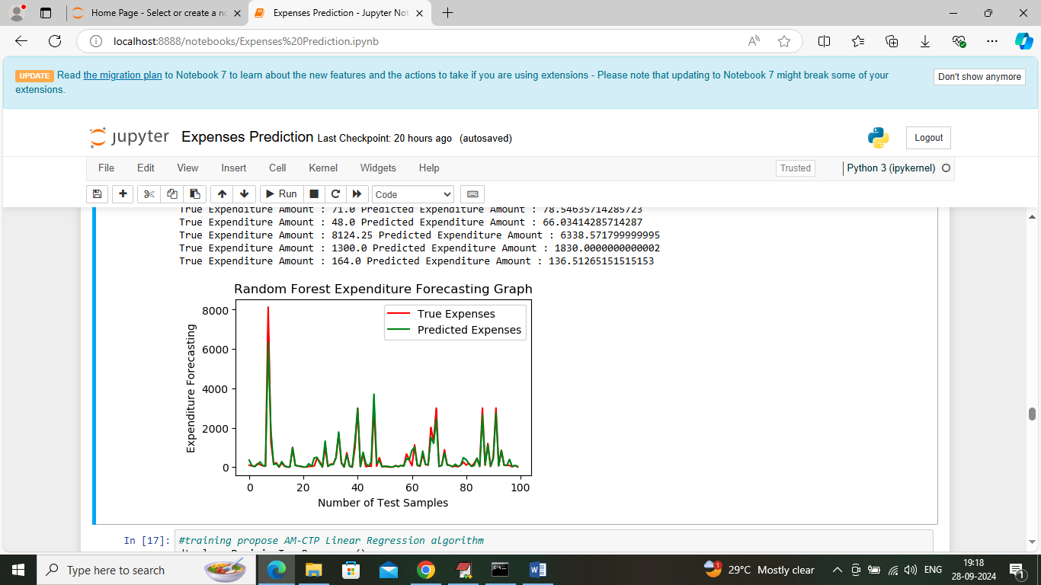
In above screen visualizing Random Forest forecasting graph where x-axis represents ‘Number of Test Data’ and y-axis represents ‘Expenses Amount’ and then red line represents true or original expenses and green line represents Forecasted expenses and can see both lines are fully overlapping with little gap si we can say Random Forest is accurate in forecasting expenses
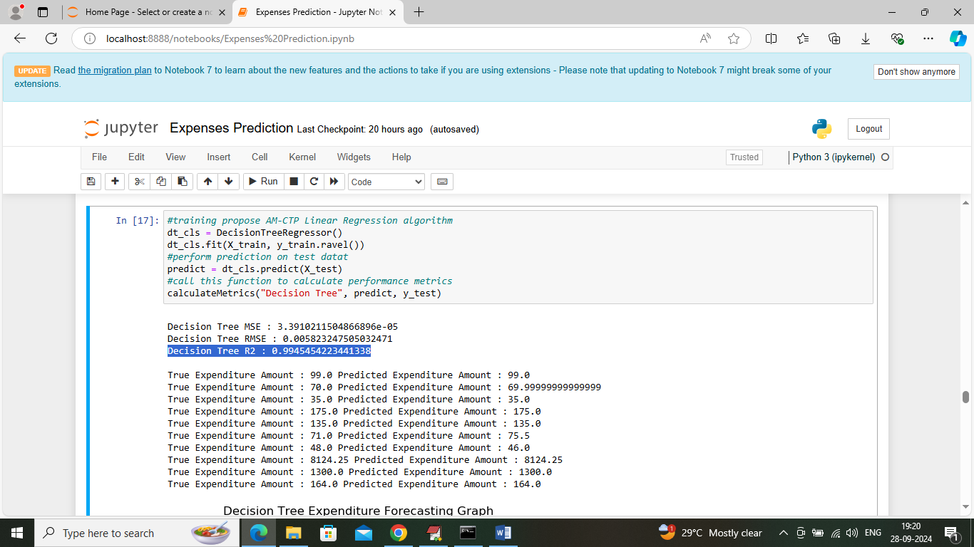
In above screen decision tree got 99% R2score and can see other metrics also along with forecasted graph
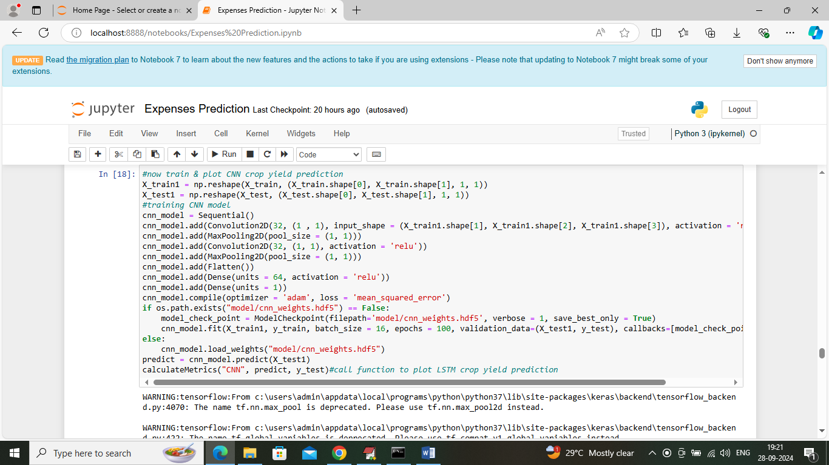
In above screen training CNN2D algorithm and after training will get below output
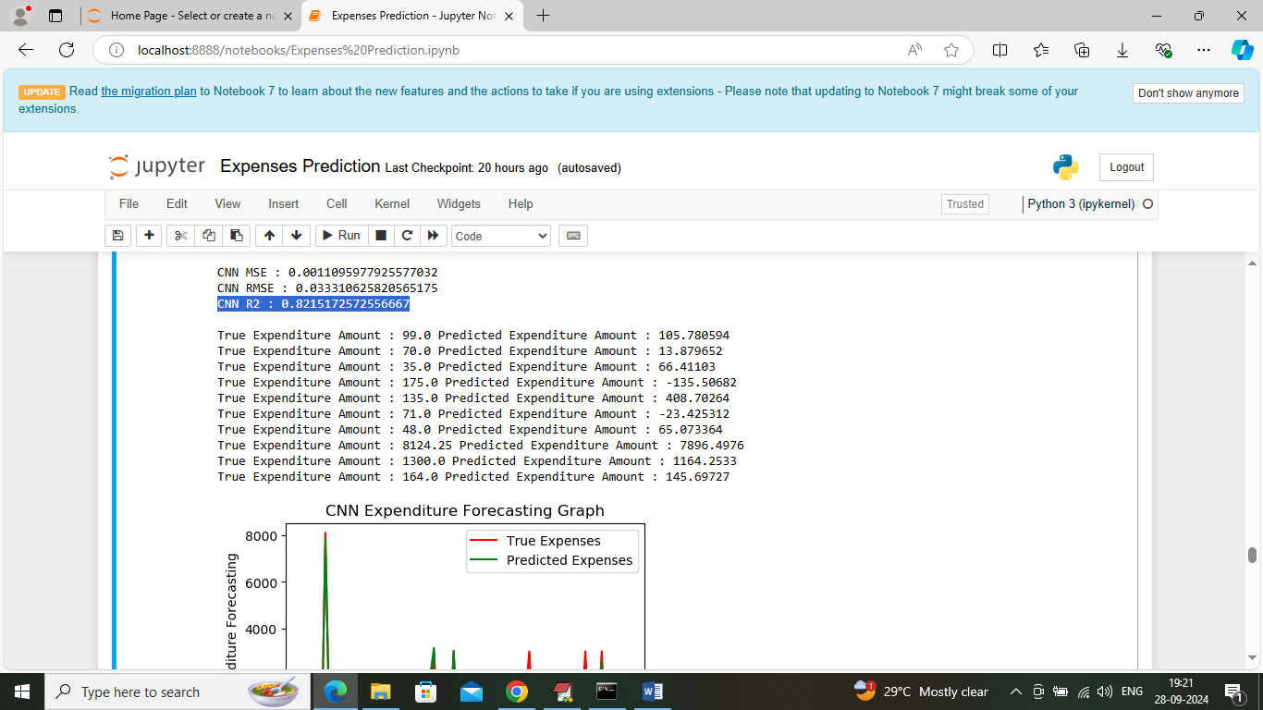
In above screen CNN2D got 82% R2score and can see other metrics also
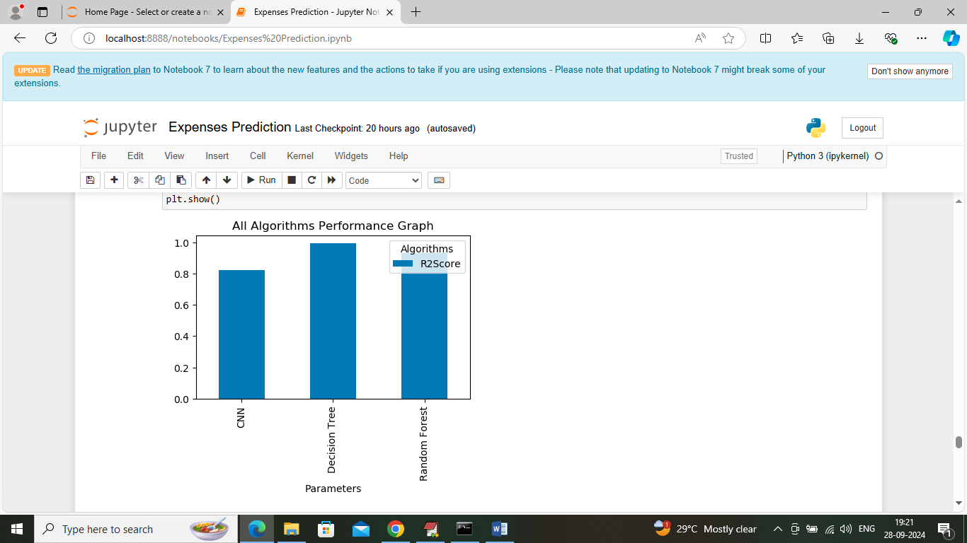
In above screen visualizing R2score graph of all algorithms where x-axis represents algorithm names and y-axis represents R2score
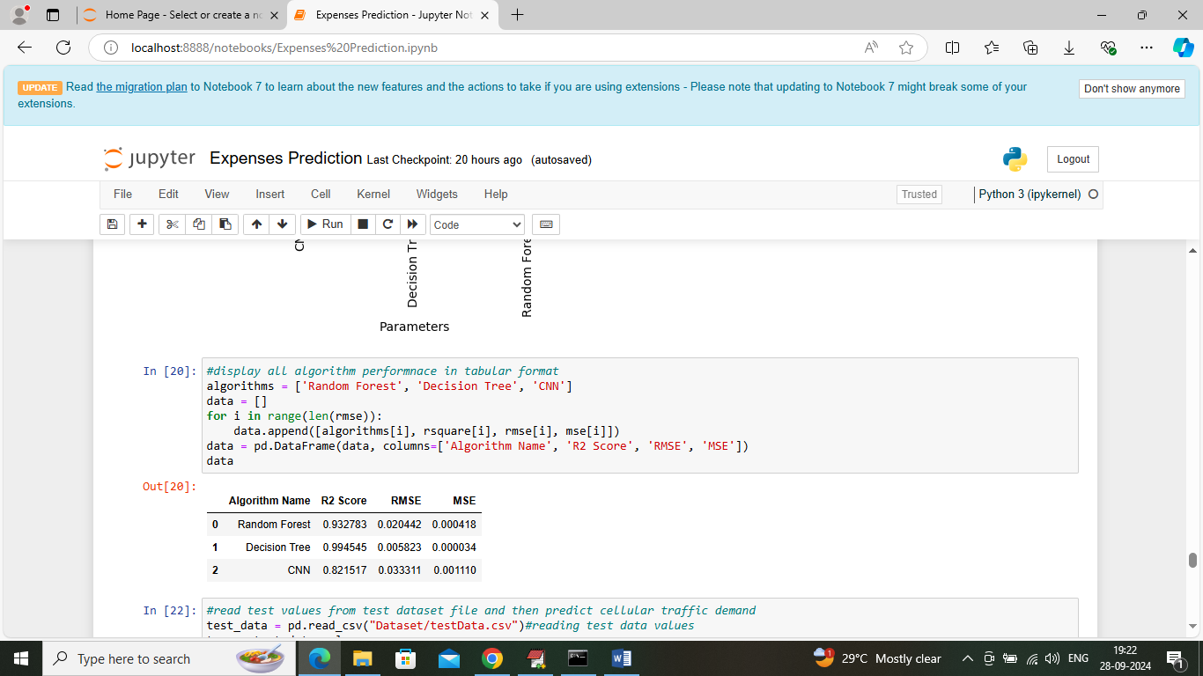
In above screen displaying all algorithm performance in tabular format
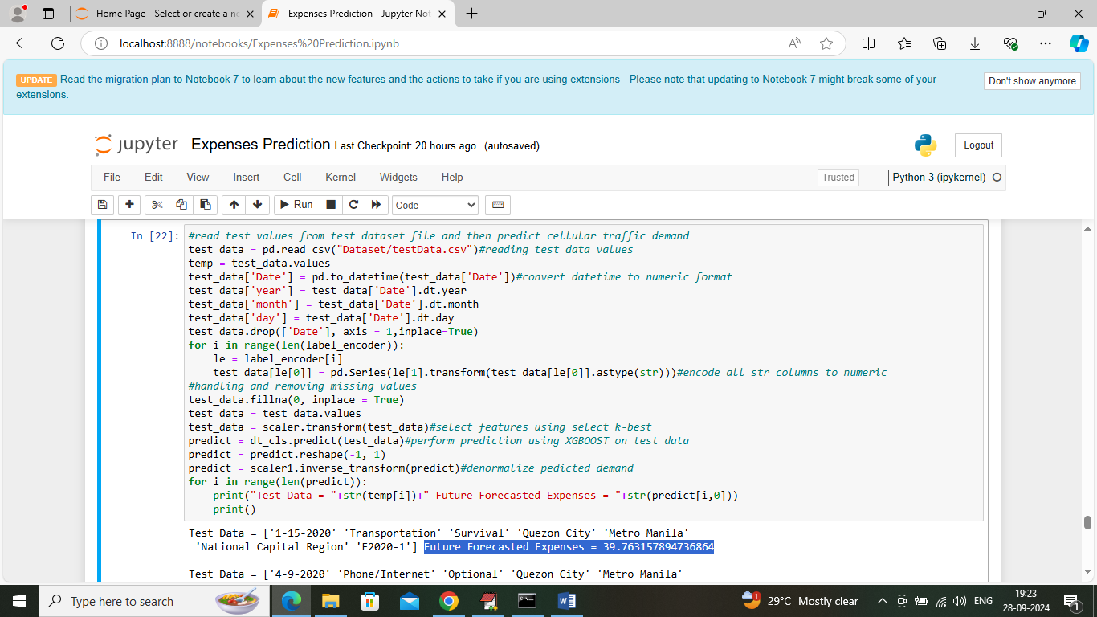
In above screen defining code which will read test data from ‘test file’ and then predict future expenses and then in output can see test data values in square bracket and blue colour text displaying predicted expenses amount
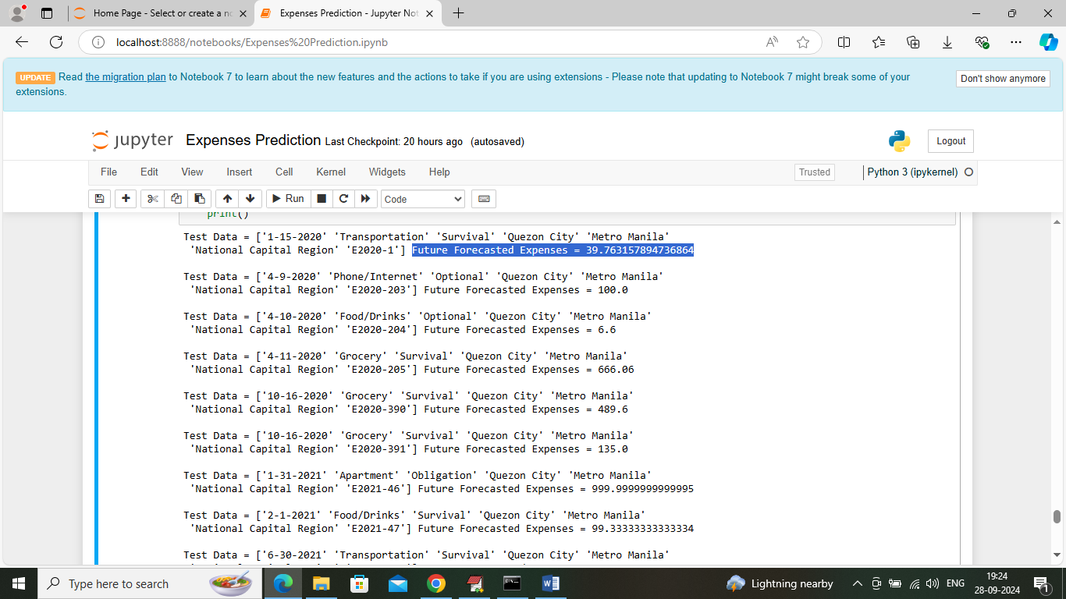
In above screen predicting expenses for different category expenses
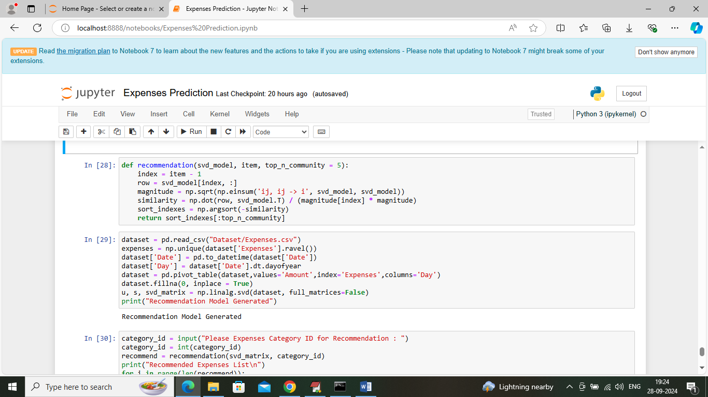
In above screen defining recommendation code and after executing this block then application will ask to input category expenses ID and then system will recommend new category expenses which you can done in future
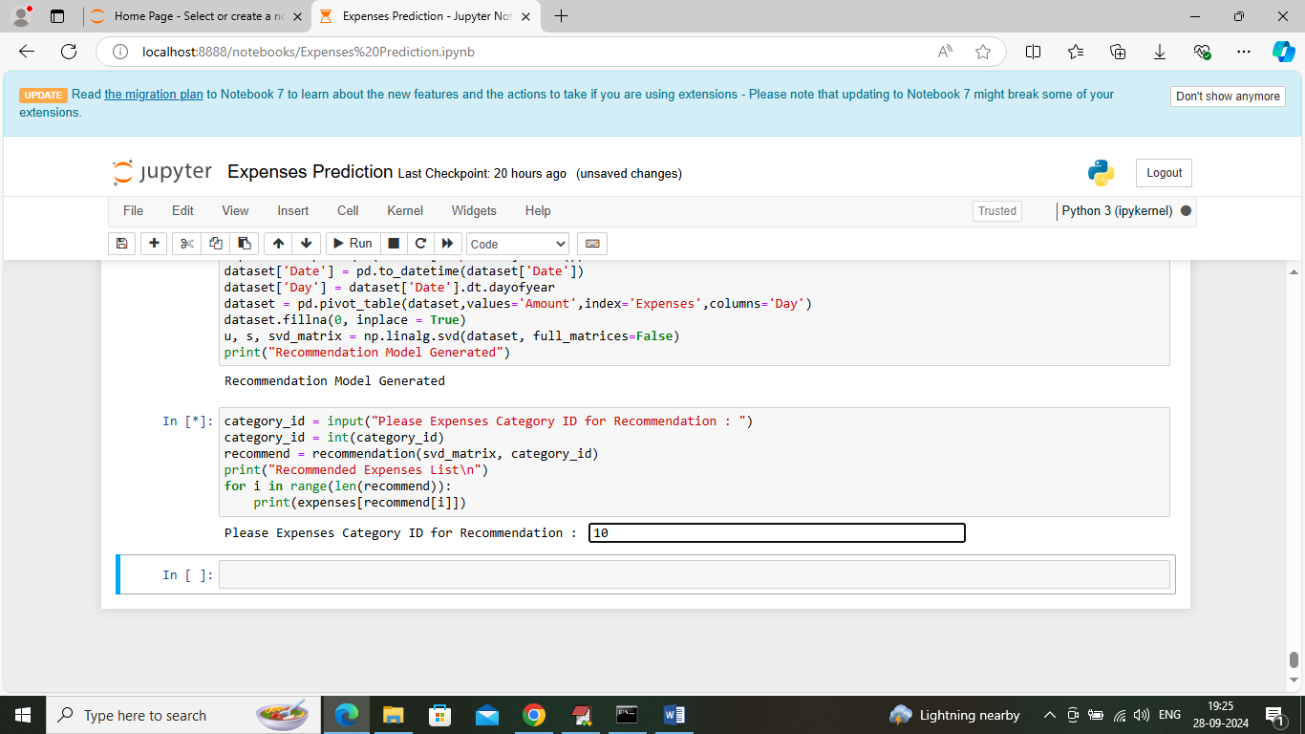
In above screen I entered category ID as 10 and then press enter key to get below output
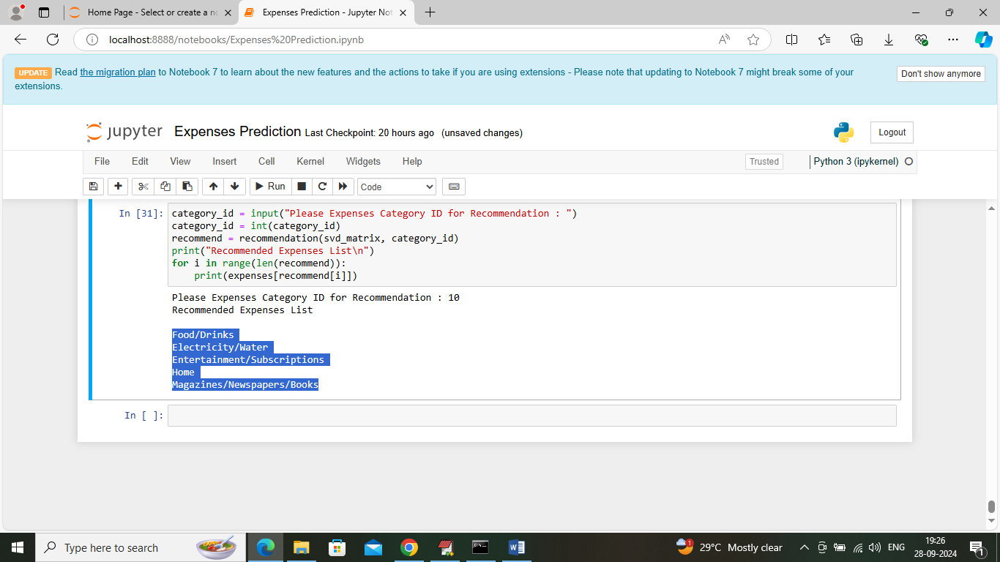
In above screen can see top 5 category names as recommendation and in below screen I am giving another category in which you can enter just by running block again
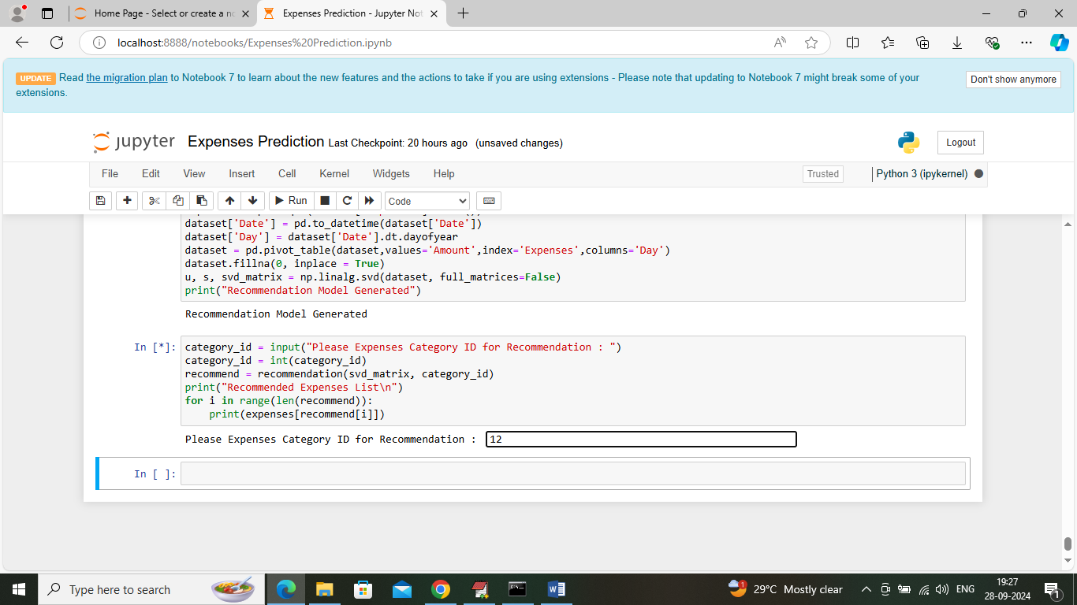
In above screen I am giving category id as 12 and then press button to get below recommendation
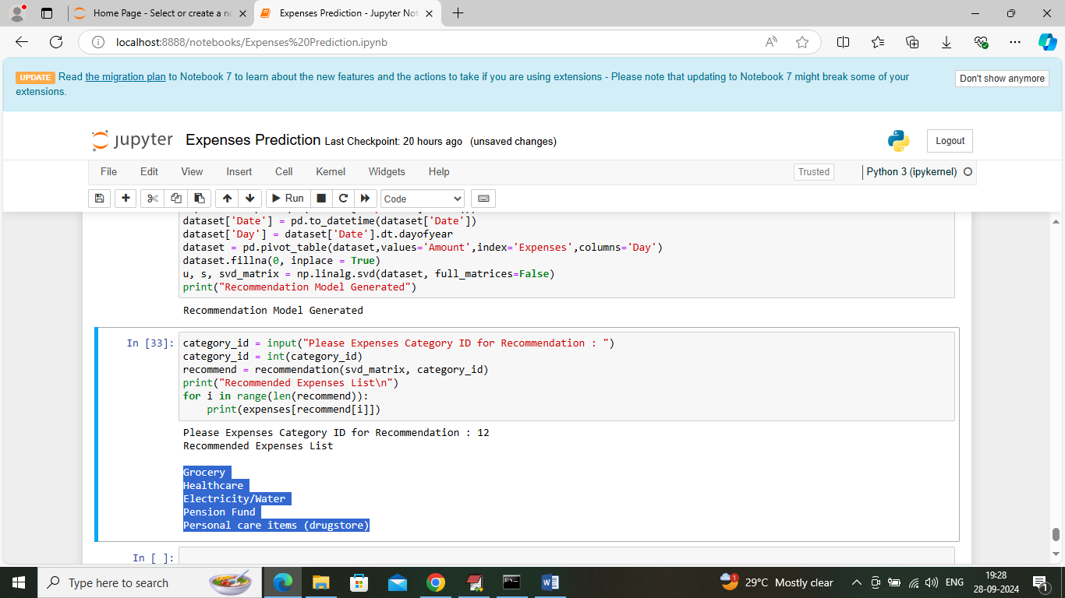
In above screen can see top 5 recommendation names for given 12 category ID. You can category id from 1 to 24.
8. CONCLUSION:
The group company’s financial management level, to a large extent, determines the fate of the corporation. The text took group company A’s ERP project as an example and studied the financial management problems of the group company which use ERP system. After diagnosis and analysis about group company A’s present financial management situation, we constructed a financial management model based on ERP system, and then proposed the basic principles and requirements of group company’s ERP implementation. Through the comparative analysis of ERP implementation effect on group company, we found that it is significant that using ERP system according to the model to promote the group to achieve comprehensive, dynamic and integrated management, and finally realize the effective integration of the resources, which comply with the long-term interests of the group. It sets an example to other group company for successfully implementing ERP project and provides some useful reference.
9. REFERENCES:
[1] Stephen, Harwood, “ERP: the implementation cycle,” Oxford, Boston: Butterworth-Heinemann, 2003, PP. 93~95.
[2] David L Olson, “ERP Managerial Issues Of Enterprise Resource Planning System,” Zhang Xiaoyu Translation, Oriental Press, 2005, PP. 34-70.
[3] Zhen Fuming, “A Study of Risk Management in ERP Implementation,” Dongmei University of finance and economics Press, 2008, PP. 85-105.
[4] Zhang Raijin, “Financial and Accounting management Innovation in IT Environment,” CHINA CITIC PRESS, 2008, PP. 201-230.
[5] Yang Xuedong, “The Impact and challenges of ERP to Enterprise Group's Financial Management,” Commercial Accounting, 2008,16, PP. 47-48.
[6] Xiao Hong, “Analysis of the ERP system’s Financial management characteristic,” Contemporary Economics, 2009, 09, PP. 138-139.
[7] Yu Meilin, “Research on the ERP-based Integrated Financial Management Mode of Enterprise Groups,” Wuhan University of Technology, 2008, PP. 12-17.
[8] Long Zhi, “The Implementation Case of Wuhan Iron and Steel Group’s Financial Management System,” http: //www. enter. com. can /article /2007/0208/A20070208433476.shtml
[9] Yu Hui, “The Application of ERP system in Enterprise Management,” Friends of Accounting, 2009, 09, PP. 71-72.
[10] Shen Kwang, “Analysis of Shandong Dong-e E-Jiao Group’s ERP System Applications,” http: //articles. works. net. can/ Erp/ article 10915. him.

